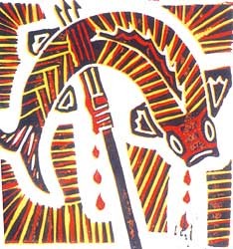

--------------------- PAINTING-------------------------------------

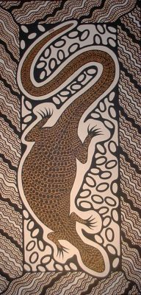
STEPS TO FOLLOW:
- Get ideas from Australian Aboriginal Art and create 3-5 thumbnail sketches for your design. You need to include an animal or aboriginal symbols in your design.
- Next, Ms. Denison will check your best design and give you the paper to begin transferring your best design.
- After you transfer your design to the construction paper, come up with a color scheme for your painting. You will either use earth tones, or analogous colors, plus black and white.
- Then you will begin painting using the “Dot Method” of the Aboriginal Tribes.
- The design should be filled with dots or lines leaving a minimal amount of the paper when you are through. (see picture)
Typical Australian Animal Choices:
----Kangaroos
----Lizards----Fish
----Frogs----Koalas
----Emus----Snakes
----Turtles----Alligators ----etc.

Typical Color Schemes:

Earth Tones (Browns, Mauves, Olive greens, etc.)
Fire Tones (Oranges, Yellows, Reds, Pinks, Purples, etc.)
Water Tones (Blues, Teals, Greens, etc.)

Student Name:  Lesson: Aboriginal Art Painting |  |  |  |  |  | Class Period:
Circle the number in pencil that best shows how well you feel that you completed that criterion for the assignment. |  | Excellent | Good | Average | Needs Improvement | Rate Yourself | Teacher’s Rating
Criteria 1 – Design/ Composition: Used Aboriginal art as inspiration for design. Created an interesting design with a strong focal point and good pattern. |  | 10 | 9 – 8 | 7 | 6 or less
Criteria 2 – Use of Animals/Symbols: Used animals or aboriginal symbols as part of your design drawn stylized, but with good quality. Aboriginal symbols told a story about your animal. |  | 10 | 9 – 8 | 7 | 6 or less
Criteria 3 – Painting Technique – Used the Aboriginal Dot Painting Technique. Strong earth tones, or Analogous color scheme with good contrast of black and white. |  | 10 | 9 – 8 | 7 | 6 or less
Criteria 4 – Effort: took time to develop idea & complete project? (Didn’t rush.) Good use of class time? |  | 10 | 9 – 8 | 7 | 6 or less
Criteria 5 – Craftsmanship – Neat, clean & complete? Skillful use of the art tools & media? |  | 10 | 9 – 8 | 7 | 6 or less
Total: 50  (possible points) | Grade: |  |  |  |  | Your Total | Teacher Total

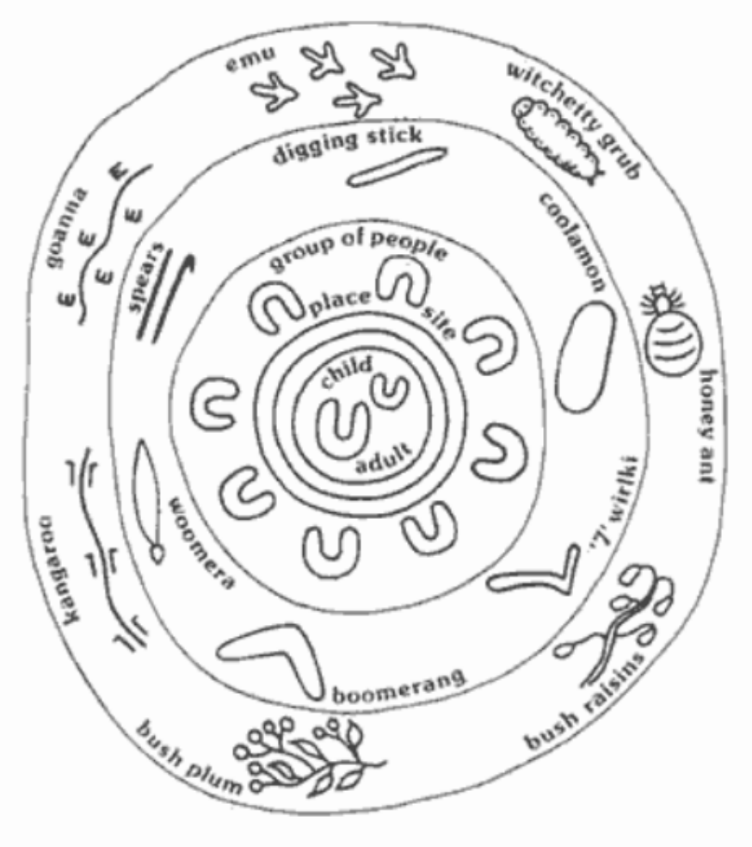
ICONOGRAPHY Art is a very important part of Aboriginal religious life, to maintain traditional representations and styles. It is still in the tradition to represent many of the desert Dreamings stories, and the sand paintings have been replaced by paintings on canvas and new styles like dot paintings and X-ray styles are the most popular modern art styles based on traditional Dreamings.
Symbols used within paintings include concentric circles, curved lines & straight lines. Concentric circles usually represent camp sites, waterholes or places of significance. Curved lines generally represent rain or water traveling underground. Straight lines may be indicative of traveling & when these lines join concentric circles it may show the pathway traveled by the ancestors. A small "U" shaped figure may represent a person & depending on the iconography next to the person determines whether it is male or female.
Tracks, whether human or animal, are often shown as they appear on the ground. Lizards and snakes are frequently seen from a topographical view - as one would see them from above.
Dotted motifs & design work have become the trademark of the contemporary Aboriginal Art movement.
Draw your three thumbnail sketches below:



