Student Name:

Lesson: Abstract Watercolor Composition
Circle the number in pencil that best shows how well you feel that you completed that criterion for the assignment. |  | Excellent | Good | Average | Needs Improvement
Criteria 1 – Composition/Dry Brush technique: Overall composition includes interesting repetition of shapes and lines. Students have the focal point off center for more interest. Dry Brush technique successfully used with colors that have been blended and mixed to make new colors. |  | 10 | 9 – 8 | 7 | 6 or less
Criteria 2 – Background: good quality mixing and use of watercolor. Background layer is pale in color, while still having some white, dry areas. |  | 10 | 9 – 8 | 7 | 6 or less
Criteria 3 – Sharpie Lines. Student utilized a fine point sharpie to add detail within the negative space. Sharpie was also used to outline watercolor contours. |  | 10 | 9 – 8 | 7 | 6 or less
Criteria 4 – Effort: took time to develop idea & complete project? (Didn’t rush.) Read the article and followed the steps within. Good use of class time? |  | 10 | 9 – 8 | 7 | 6 or less
Criteria 5 – Craftsmanship – Neat, clean & complete? Skillful use of the art tools & media? |  | 10 | 9 – 8 | 7 | 6 or less
Total: 50  (possible points) /50 pts | Grade:
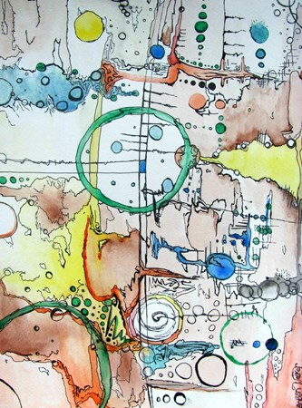
- Create 3-4 various colors by MIXING the paint together. Add lots of water to make it very pale.
- Next, layer large sections of water over the blank paper. Leave some areas dry.
- Drop in wet color into the wet areas and force it to bleed around within the background wet areas.
- Students will use a dry point technique using intense mixed paint to add lines, and shapes over the background layer of the composition. Students will use repetition to add interest.
- Finally, students will use black, fine point, sharpie to add detail to the background and around the contour paint washes and dry-brush.

