Student Name:
Lesson: Clay Critter
Circle the number in pencil that best shows how well you feel that you completed that criterion for the assignment. |  | Excellent | Good | Average | Needs Improvement
Criteria 1 – Vessel Form: Created a successful vessel form with a slit for the phone. |  | 10 | 9 – 8 | 7 | 6 or less
Criteria 2 – Additive Features: Created expressive features and additions to add onto the critter. |  | 10 | 9 – 8 | 7 | 6 or less
Criteria 3 – Surfacing: evenly coated glaze coat. |  | 10 | 9 – 8 | 7 | 6 or less
Criteria 4 – Effort: took time to develop idea & complete project? (Didn’t rush.) Good use of class time? |  | 10 | 9 – 8 | 7 | 6 or less
Criteria 5 – Craftsmanship – Neat, clean & complete? Skillful use of the art tools & media? |  | 10 | 9 – 8 | 7 | 6 or less
Total: 50  (possible points) | Grade:
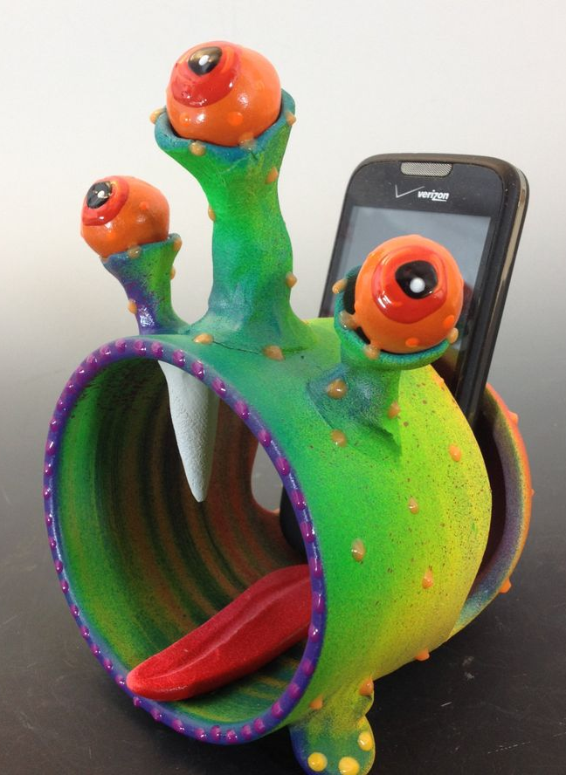
Clay Critter
Step 1: First create two expressive designs of critters. You can use monster faces, part-animal faces, or any other distorted face.

Step 2: Create one large pinch pot.

Step 3: Next create a hole/slit in the top to hold the cell phone.

Step 4: Slip and score on two feet on the bottom.

Step 5: Add features to your critter. (teeth eyes, tongue, etc.)

Step 6: Wait until the critter is bone dry and fire it in the kiln to harden.

Step 7: Then paint the vessel with colored glaze.

Step 8: Once the vessel is fired a second time, it is finished, and can be graded.

