Student Name:  Lesson: Illuminated Letter Project |  |  | Class Period:
Circle the number that best shows how well you feel that you completed that criterion for the assignment. |  | Excellent | Good | Average |  | Needs Improvement
Criteria 1 – Design/ Composition: A variation of lines are used moving the eye around the page. An interesting overall desgin with a strong focal point. |  | 10 | 9 – 8 | 7 |  | 6 or less
Criteria 2 – Color Application: Colored pencils are used so that the color is bright and stands out like paint on the page. Pencils have been blended together to create new colors. Contrasting colors used on the outlines to make shapes stand out. |  | 10 | 9 – 8 | 7 |  | 6 or less
Criteria 3 – Pattern, Pattern, Pattern! – Interesting complex patterns have been used within the image. Some areas have large patterns, and some have smaller patterns. |  | 10 | 9 – 8 | 7 |  | 6 or less
Criteria 4 – Copper relief – Copper tools have successfully created areas both pushed in and raised out. |  | 10 | 9 – 8 | 7 |  | 6 or less
Criteria 5– Effort: took time to develop idea & complete project? (Didn’t rush.) Good use of class time? |  | 10 | 9 – 8 | 7 |  | 6 or less
Criteria 6 – Craftsmanship – Neat, clean & complete? Skillful use of the art tools & media? |  | 10 | 9 – 8 | 7 |  | 6 or less
Total: 60  (possible points) | Grade: /60 = |  | Your Total |  | Teacher Total
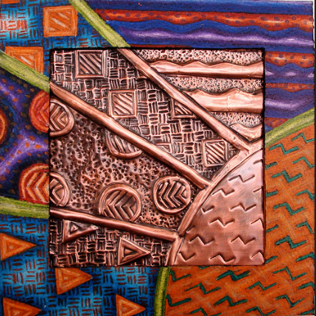
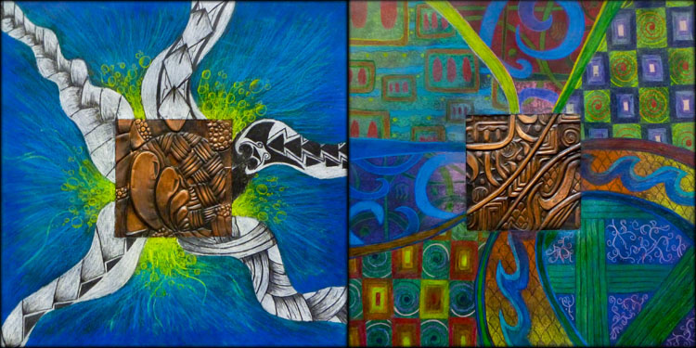
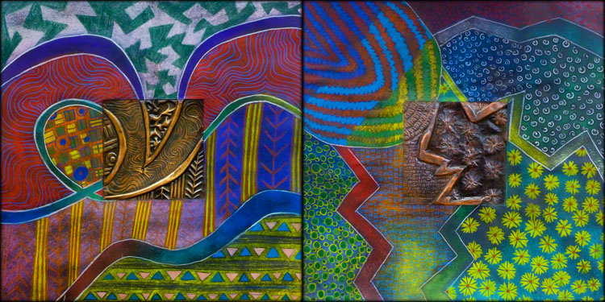
STEPS TO FOLLOW:

- First, students will take a 5x5 white square and tape it to the middle of the black paper.
- Then, they will create large lines that cross over the black and white areas.
- Lines and Pattern will fill in the lines and create a texture on the white and black areas.
- Next, students will transfer the WHITE paper design onto a 5x5 copper square.
- Using pushing tools, students will create a relief on the copper, pushing some areas out and some areas back.
- Students will also fill in the black areas with colored pencil shading.
- Finally, students will add a black acryllic paint on top of the copper. While it is still wet, students will wipe the black paint off of the raised areas with a damp paper towel.
Repoussé is a type of low relief sculpture in which form projects from a background. Repoussé is a French word which means to push.

