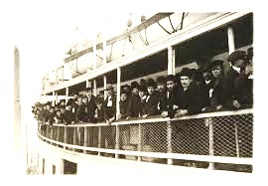
----------------an artist inspiration-------------------------------------
STEPS TO FOLLOW:
- Pick one of the artists or art cultures listed to research. (this will be the style your artwork will resemble)
- You will go to the computer lab and research about that artist or cultural artwork using the research guide.
- Next, you will pick a theme of either Crossroads, Travel OR Cultural Harmony to create as the subject matter for your work of art.
- Figure out what media you would like to create your work in and plan out your imagery.
- Use the Internet to gather imagery sources for your thumbnail sketches.
- Create at least 2 thumbnails in your sketchbook and show them to Mrs. Denison before you begin creating your final piece.
- You will be able to choose a background for your piece of a map, music, newspaper, or texture before you begin your main contour lines.
- Be sure your style is mimicking the style of your chosen artist or art culture.
- When you finish your artwork, you will turn in your research/planning guide along with your rubric and final artwork.

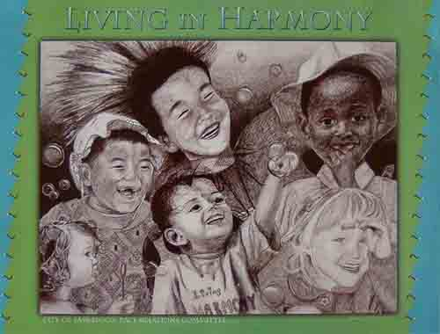

Student Name:

Lesson: Crossings and Cultural Harmony
Circle the number in pencil that best shows how well you feel that you completed that criterion for the assignment. |  | Excellent | Good | Average | Needs Improvement
Criteria 1 – Composition/Depth: Successful overall composition of your themed environment. Subject matter well placed within the environment. Student used a variety of values to create depth. They should have lights, darks, and midtones well developed within the artwork. |  | 10 | 9 – 8 | 7 | 6 or less
Criteria 2 – Incorporation of thematic imagery: Student utilized imagery from either “Crossroads/Travel” or “Cultural Harmony”. These could be subtle or blatant. |  | 10 | 9 – 8 | 7 | 6 or less
Criteria 3 – Style. Successful creation of artwork in the style of the artist/ art culture you researched. |  | 10 | 9 – 8 | 7 | 6 or less
Criteria 4 – Research: Student planned out the artwork by both researching the style of the artist/ art culture used as well as gathering information about the imagery they were planning to use. |  | 10 | 9 – 8 | 7 | 6 or less
Criteria 5 – Effort: took time to develop idea & complete project? (Didn’t rush.) Read the article and followed the steps within. Good use of class time? |  | 10 | 9 – 8 | 7 | 6 or less
Criteria 6 – Craftsmanship – Neat, clean & complete? Skillful use of the art tools & media? |  | 10 | 9 – 8 | 7 | 6 or less
Total: 60  (possible points) /60 pts | Grade:

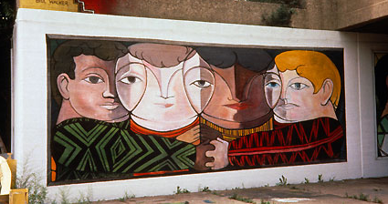
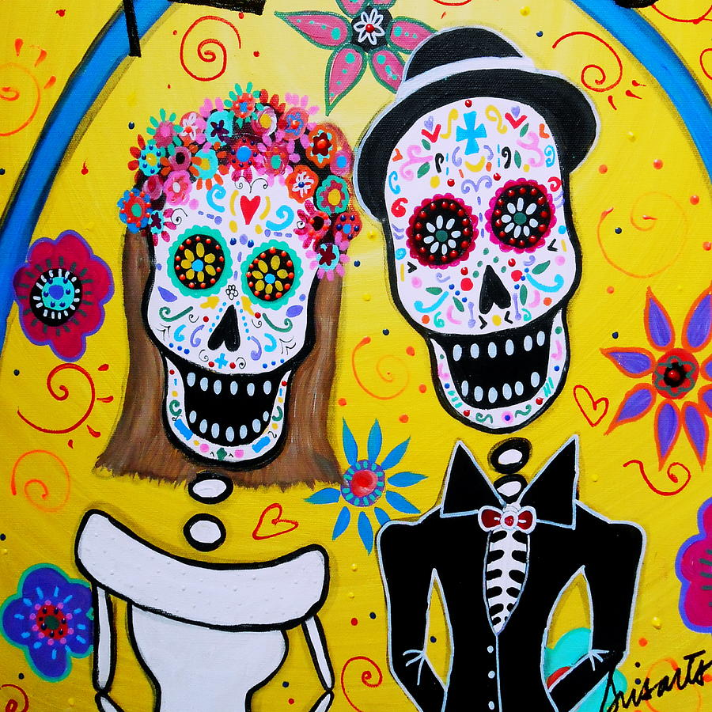
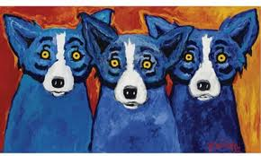
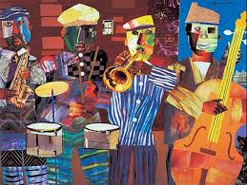
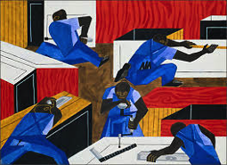
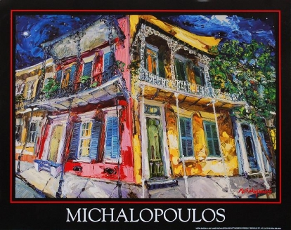
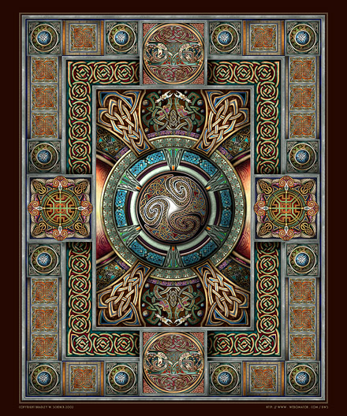
Latin American Art:

Day of the Dead

Cajun/New Orleans Artists:

James Michalopoulos

George Rodrigue

Harlem Renaissance Art:

Romare Bearden

Jacob Lawrence

Irish/ Celtic Art

Illuminations

