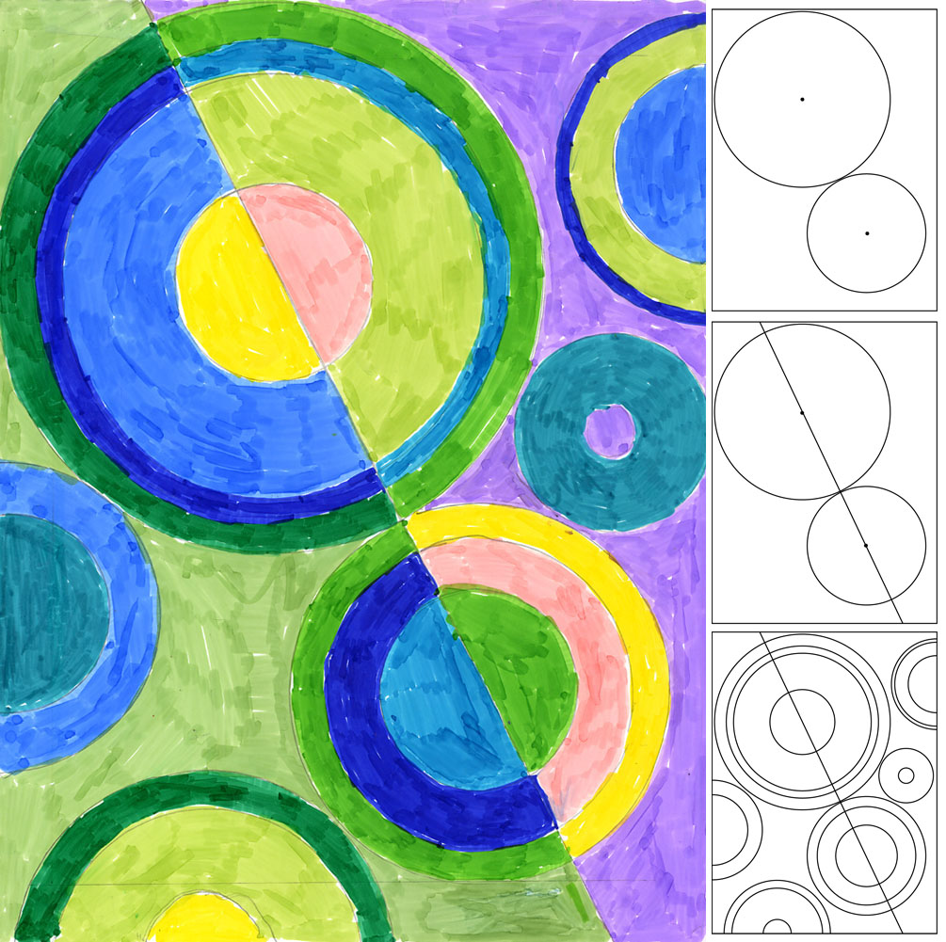
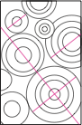
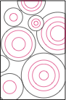
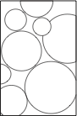
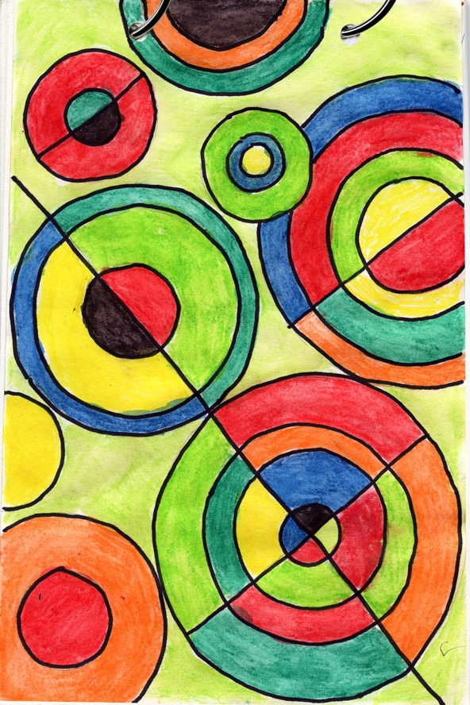
- Fill a page with circles. Use the circle compass to create even circles.
- Fill each circle with concentric circles to make large and small rings.
- Draw at least 3 lines with a ruler that dissects some of the circles.
- Use a black permanent marker to trace all the lines and circles.
- Use watercolors to paint the inside of each section of the circles.
- Add watercolor colored pencils for shading.

Sonia Delaunay (1885–1979) was a Jewish-French artist who was famous for her use of strong colors and geometric shapes. She liked to paint, design fabrics and stage designs. Sonia was the first living female artist to have a retrospective exhibition at the Louvre in Paris in 1964.

Student Name:

Lesson: Delaunay Circles
Circle the number in pencil that best shows how well you feel that you completed that criterion for the assignment. |  | Excellent | Good | Average | Needs Improvement
Criteria 1 – Composition: Overall composition includes interesting concentric circles with dynamic diagonal lines. |  | 10 | 9 – 8 | 7 | 6 or less
Criteria 2 – Watercolors: good quality and use of watercolor. Each section has a different shade of watercolor. |  | 10 | 9 – 8 | 7 | 6 or less
Criteria 3 – Shading of color. Student utilized watercolor colored pencils to add shading within the color sections. |  | 10 | 9 – 8 | 7 | 6 or less
Criteria 4 – Effort: took time to develop idea & complete project? (Didn’t rush.) Read the article and followed the steps within. Good use of class time? |  | 10 | 9 – 8 | 7 | 6 or less
Criteria 5 – Craftsmanship – Neat, clean & complete? Skillful use of the art tools & media? |  | 10 | 9 – 8 | 7 | 6 or less
Total: 50  (possible points) /50 pts | Grade:

