Student Name:
Lesson: Face Vessels
Circle the number in pencil that best shows how well you feel that you completed that criterion for the assignment. |  | Excellent | Good | Average | Needs Improvement
Criteria 1 – Vessel Form: Created a successful vessel form with a neck and handle. |  | 10 | 9 – 8 | 7 | 6 or less
Criteria 2 – Expressive Face: Created an expressive thumbnail sketch that translated to vessel. Facial features added and then formed into the vessel itself. |  | 10 | 9 – 8 | 7 | 6 or less
Criteria 3 – Surfacing: evenly coated glaze coat. |  | 10 | 9 – 8 | 7 | 6 or less
Criteria 4 – Effort: took time to develop idea & complete project? (Didn’t rush.) Good use of class time? |  | 10 | 9 – 8 | 7 | 6 or less
Criteria 5 – Craftsmanship – Neat, clean & complete? Skillful use of the art tools & media? |  | 10 | 9 – 8 | 7 | 6 or less
Total: 50  (possible points) | Grade:
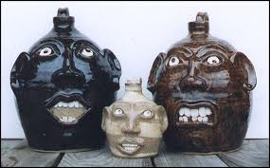
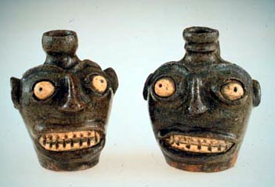
Face Vessels
Step 1: First create two expressive designs of expressive faces and vessels you might use. Be as expressive as possible in your design. You can use monster faces, part-animal faces, or any other distorted face.

Step 2: Create two pinch pots and then score and slip them together. (see Mrs. Denison’s demo)

Step 3: Next create a hole in the top for a spout. Then create a handle or two.

Step 4: Next sculpt your face. Add coils for the nose, lips, ears and eyebrows. Add or subtract clay for the teeth and eyes.

Step 5: Once the vessel is dried and bisque-fired.

Step 6: Then paint the vessel with colored glaze.

Step 7: Once the vessel is fired a second time, it is finished, and can be graded.

