Student Name:
Assignment:
Fibers Collage
Circle the number in pencil that best shows how well you feel that you completed that criterion for the assignment. |  | Excellent | Good | Average | Needs Improvement
Criteria 1 – Composition- Students have created a balanced abstract composition with a main focal point. |  | 10 | 9 – 8 | 7 | 6 or less
Criteria 2 – Space/ Layers. Thought is given to how focal point relates to background. Layered from back to front. |  | 10 | 9 – 8 | 7 | 6 or less
Criteria 3 – Use of linear details. Use string, yarn or other small detailed fabric to create movement within the overall design of the collage. |  | 10 | 9 – 8 | 7 | 6 or less
Criteria 4 – Effort: took time to develop idea & complete project? (Didn’t rush.) Good use of class time? |  | 10 | 9 – 8 | 7 | 6 or less
Criteria 5 – Craftsmanship – Neat, clean & complete? Skillful use of the art tools & media? |  | 10 | 9 – 8 | 7 | 6 or less
Total: 50  (50 possible points) | Grade:
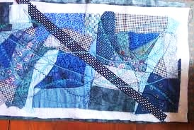
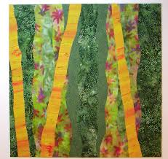
Objective: To create an abstract design collage out of fabric and fibers, creating a strong focal point with linear details to create movement within the design.
Fibers Collage
Steps
- Start by picking out fabrics that follow a “color story.” (These are fabrics that all would work together within a color scheme.)
- Collect a fabrics using a variety of sizes and shapes.
- Begin laying out the fabrics on the background to format the design.
- Use larger fabrics in the background first.
- Then begin layering fabrics on top, forming a design with a strong focal point.
- NOW, begin gluing down your fabrics starting with the background first. (you will use a watered down glue and apply it with a paint brush.)
- Finally, you will add linear movement by applying lines with yarn, or small fibers on the top layer. Try to direct the viewer’s eye to the focal point.

