Student Name:

Lesson: Frank Lloyd Wright Stained Glass
Circle the number in pencil that best shows how well you feel that you completed that criterion for the assignment. |  | Excellent | Good | Average | Needs Improvement
Criteria 1 – Composition: Overall composition includes interesting repetition of shapes and lines. Composition based on Frank Lloyd Wright, but NOT a copy, it is your own design. |  | 10 | 9 – 8 | 7 | 6 or less
Criteria 2 – Line/Shape Quality: black sharpie is neatly added. Lines are neatly created with a ruler or a circle compass. |  | 10 | 9 – 8 | 7 | 6 or less
Criteria 3 – Sharpie colors. Student utilized no more than 4 colors of sharpie to add interest and color to select sections of the composition. At least one third of the composition is still left clear. |  | 10 | 9 – 8 | 7 | 6 or less
Criteria 4 – Effort: took time to develop idea & complete project? (Didn’t rush.) Read the article and followed the steps within. Good use of class time? |  | 10 | 9 – 8 | 7 | 6 or less
Criteria 5 – Craftsmanship – Neat, clean & complete? Skillful use of the art tools & media? |  | 10 | 9 – 8 | 7 | 6 or less
Total: 50  (possible points) /50 pts | Grade:
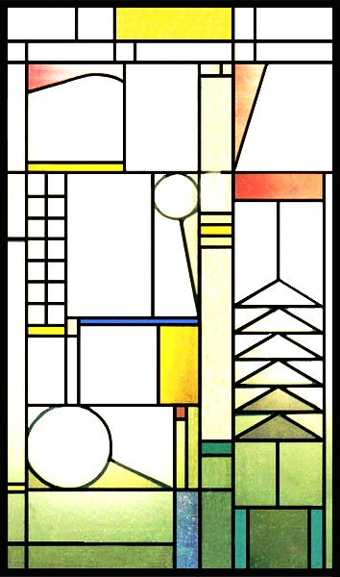
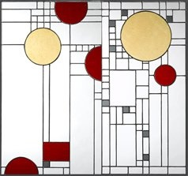
- Take a look at the various examples of stained glass windows created by Frank Lloyd Wright.

- Next create your own version of these in 2-3 thumbnail sketches in your sketchbook.

- Take the best one and enlarge it on the white paper. This will be your rough draft. You need to use rulers and circle compasses for good craftsmanship.

- Once the rough draft is complete, you will receive a transparency sheet from Mrs. Denison. Paperclip this directly to the rough draft and trace over the main lines with black sharpie.

- Next, choose up to 4 colors and add colored sharpie to color in select areas. (craftsmanship is important!)

- When complete, add a black frame around the edges with construction paper and turn in to the class box along with your rubric.

---------------- STAINED GLASS -------------------------------------

