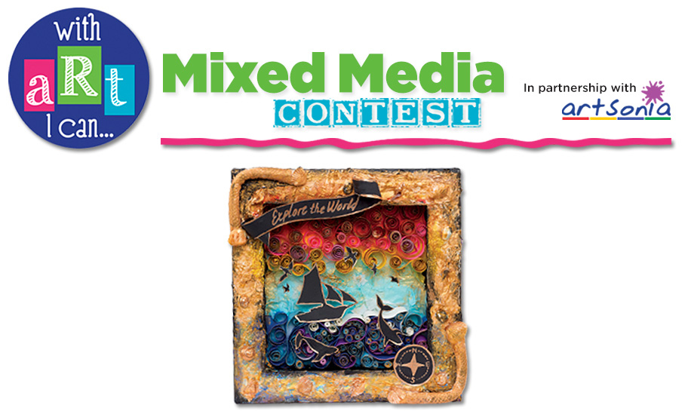

**SELECT YOUR INSPIRATION:**

Shrines can be created to honor a source of inspiration and admiration. For our project, we are going to think about something inspiring. Think about an inspirational quote, poem, or song to use as the theme of your shrine.



* Research a list of inspirational quotes or songs.
* Narrow it down to one quote, poem or song and then brainstorm a list of words that pop into your head when you read through your text.
* Search for and print images that relate to your subject.
* Collect and/or create items that you will include in your assemblage

**COLLECT YOUR MATERIALS**

* Images related to your inspirational quote, poem, or song.
* The text of the quote, poem, song.
* Rhinestones, beads, charms, etc.
* Glass pebbles
* Glitter
* Tiny mirrors
* Basic crafts supplies, glue, scissors, toothpicks, decorative papers, ribbon, etc.
* Paper Quilling



**ASSEMBLE THE SHRINE**

1. Sand the entire tin so that gesso will stick to the metal.
2. Add a background paper or tissue collage and tint with watercolor.
3. Adhere a photo or image of the theme inside the box or tin.
4. Add Text
5. Add chosen embellishments: beads, glass pebbles, words, charms,etc.
6. Paint or cover the outside of the box or tin; let dry if needed
7. Embellish the outside as well.

|  |  |  |  |  |  |
| --- | --- | --- | --- | --- | --- |
| **Student Name:** | | |  | | |
| Assignment: **Altoid Shrine** | | |  | | |
| Circle the number **in pencil** that best shows how well you feel that you completed that criterion for the assignment. | | **Excellent** | **Good** | **Average** | **Needs Improvement** |
| **Criteria 1** – Chosen theme/inspirational text well chosen and shown within. | | 10 | 9 – 8 | 7 | 6 or less |
| **Criteria 2** –  Overall Design/Collection of assembled items: use of elements and principles of design to create a focal point with supportive elements. | | 10 | 9 – 8 | 7 | 6 or less |
| **Criteria 3** – Background- layers used to create depth and interest. | | 10 | 9 – 8 | 7 | 6 or less |
| **Criteria 4** – **Effort**: took **time** to develop idea & complete project? (Didn’t rush.) Good use of class time? | | 10 | 9 – 8 | 7 | 6 or less |
| **Criteria 5** – **Craftsmanship** – Neat, clean & complete? Skillful use of the art tools & media? | | 10 | 9 – 8 | 7 | 6 or less |
| **Total: 50** (possible points) |  |  |  |  |  |

**Place Altoid Tin here.**

(Fill out this sheet and then wrap it around your altoid tin to turn in.)