Student Name:

Lesson: Koi Fish: Step-by-Step
Circle the number in pencil that best shows how well you feel that you completed that criterion for the assignment. |  | Excellent | Good | Average | Needs Improvement
Criteria 1 – Accuracy of koi fish drawing: Successful overall drawing of koi fish following step-by step directions. |  | 10 | 9 – 8 | 7 | 6 or less
Criteria 2 – Additional Elements: Student utilized unique individualized elements to decorate around the fish. |  | 10 | 9 – 8 | 7 | 6 or less
Criteria 3 – Color. Student followed the directions to add color and blend with plain water. Outlines were added afterward with black. |  | 10 | 9 – 8 | 7 | 6 or less
Criteria 4– Effort: took time to develop idea & complete project? (Didn’t rush.) Read the article and followed the steps within. Good use of class time? |  | 10 | 9 – 8 | 7 | 6 or less
Criteria 5 – Craftsmanship – Neat, clean & complete? Skillful use of the art tools & media? |  | 10 | 9 – 8 | 7 | 6 or less
Total: 50  (possible points) /50 pts | Grade:
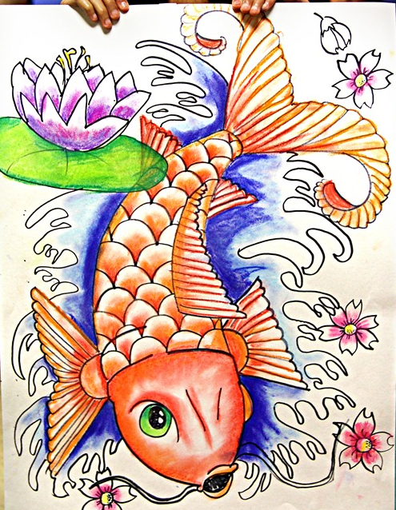
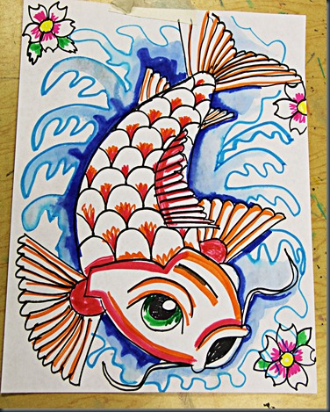
-----------------Step-by-Step-------------------------------------

STEPS TO FOLLOW:
- This project is all about how well you follow written directions.
- Mrs. Denison will hand you a packet with step-by-step directions on how to draw a Koi Fish.
- You will follow the directions as accurately as possible to create your own fish on the 12x18 drawing paper.
- You will add color and blend it with water as the directions state.
- Finally, you will add your own decoration such as flowers, leaves, etc. to finalize your drawing.
- Good luck!

