Student Name:  Lesson: Leaf Resist/Etching |  |  | Class Period:
Circle the number that best shows how well you feel that you completed that criterion for the assignment. |  | Excellent | Good | Average |  | Needs Improvement
Criteria 1 – Leaf Drawing: drew at least two leaves with accuracy adding detail without tracing. |  | 10 | 9 – 8 | 7 |  | 6 or less
Criteria 2 – Placement of leaves with background: Leaves placed on page so that there is negative space behind. Background shows shading for more value. |  | 10 | 9 – 8 | 7 |  | 6 or less
Criteria 3 – Crayon Etching: Crayon is layered on in an interesting way. Colors are blended and detail etched back into the crayon. |  | 10 | 9 – 8 | 7 |  | 6 or less
Criteria 4 – ink/resist – Resist is added to age the leaves. Not covered up too much of the leaf with the ink wash. |  | 10 | 9 – 8 | 7 |  | 6 or less
Criteria 5 – Effort: took time to develop idea & complete project? (Didn’t rush.) Good use of class time? |  | 10 | 9 – 8 | 7 |  | 6 or less
Criteria 6 – Craftsmanship – Neat, clean & complete? Skillful use of the art tools & media? |  | 10 | 9 – 8 | 7 |  | 6 or less
Total: 60  (possible points) | Grade: /60 = |  | Your Total |  | Teacher Total
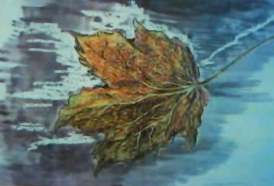
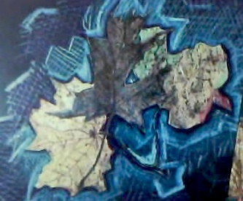
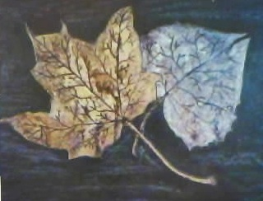
STEPS TO FOLLOW:
- Students will pick three leaves to draw out on white paper. Students will draw what they see NOT trace the leaves onto the paper.
- Students will then trace over the drawing with sharpie marker.
- Next, the students will layer MANY shades of crayon on top of the leaf they drew adding shading with darker colors.
- The students will then use the scratch tools to etch into the crayon layers they have drawn to add more detail.
- Watercolor will then be added which will resist the crayon to create an interesting effect on the leaf, making it look aged.
- The leaves will be cut out and glued to the grey background.
- Shading will be added to the background with chalk pastel in contrasting colors.

-------------- Crayon Resist/Etching -------------------------------------

