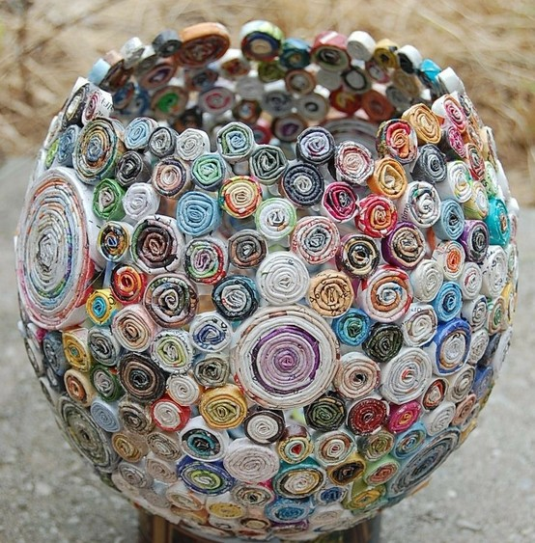
Magazine Bowl

Just a few simple steps:
- Blow up a balloon.
- Cut strips of magazines, fold in half.
- Roll up and glue to balloon.
- When all dry, pop balloon.
- Finally, create a “foot” for your bowl using another magazine spiral.

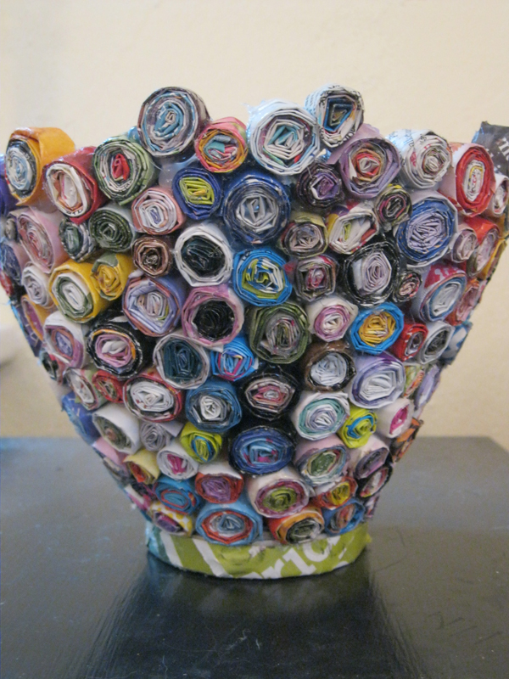

Student Name:  Lesson: Magazine Bowl |  |  | Class Period:
Circle the number that best shows how well you feel that you completed that criterion for the assignment. |  | Excellent | Good | Average |  | Needs Improvement
Criteria 1 – Procedure: Followed the simple steps to create magazine bowl. |  | 10 | 9 – 8 | 7 |  | 6 or less
Criteria 2 – Finishing: Filled in all the gaps with smaller beads. Made sure all beads were glued together. Created a “foot” for the bowl to sit up on without tipping. |  | 10 | 9 – 8 | 7 |  | 6 or less
Criteria 3 – Magazine Design – Created an interesting design using different sizes of spirals. |  | 10 | 9 – 8 | 7 |  | 6 or less
Criteria 4 – Effort: took time to develop idea & complete project? (Didn’t rush.) Good use of class time? |  | 10 | 9 – 8 | 7 |  | 6 or less
Criteria 5 – Craftsmanship – Neat, clean & complete? Skillful use of the art tools & media? |  | 10 | 9 – 8 | 7 |  | 6 or less
Total: 50  (possible points) | Grade: /50 = |  | Your Total |  | Teacher Total
