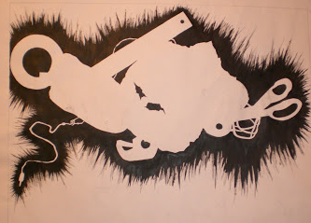

-------------Yarn Painted Background-------------------------

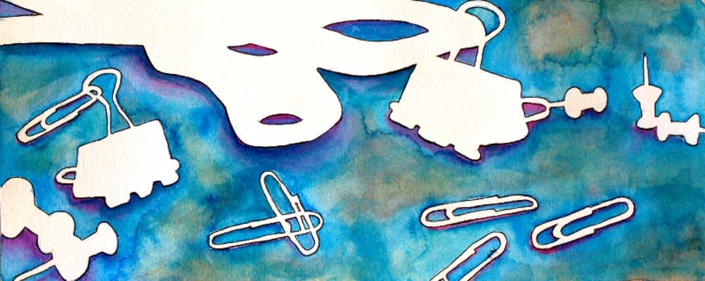
STEPS TO FOLLOW:
- First Mrs. Denison will introduce negative space drawing. Students will practice creating a negative space drawing in their sketchbook.
- Students will then create 2 enlarged negative space drawings of still life objects onto poster board. (one drawing on each side)
- Next students will pick the best drawing and create shapes within the negative space. (geometric or organic shapes)
- Students will then create a color selection of yarn using only 3 ANALAGOUS colors. (tints and shades of those colors are allowed and encouraged)
- Students will draw along the boarders of each shape in the negative space with glue and place the yarn along the glue line, cutting the yarn where needed to fill each shape.
- Students will keep filling each background shape with yarn, leaving the objects the white of the paper.

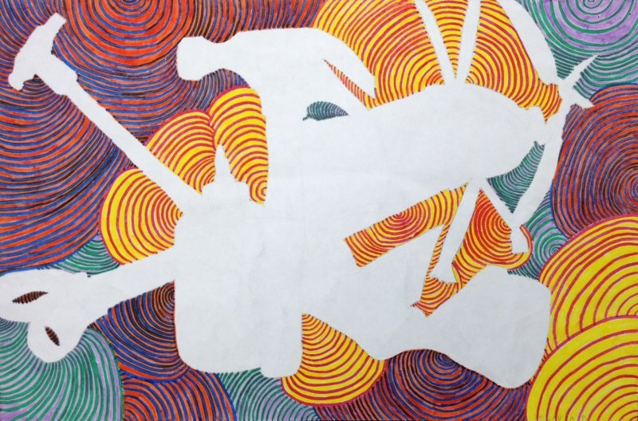

Student Name:  Lesson: Yarn Painting |  |  | Class Period:
Circle the number that best shows how well you feel that you completed that criterion for the assignment. |  | Excellent | Good | Average |  | Needs Improvement
Criteria 1 – Negative Space Drawing: student has correctly drawn the objects as a negative space drawing and objects appear accurate. |  | 10 | 9 – 8 | 7 |  | 6 or less
Criteria 2 – Background Shapes: Students has used either organic or geometric shapes to fill the negative space using an analogous color scheme. |  | 10 | 9 – 8 | 7 |  | 6 or less
Criteria 3 – Yarn Painting Technique – The interior design of painting is completely filled with a variety of colored yarn. |  | 10 | 9 – 8 | 7 |  | 6 or less
Criteria 4 – Effort: took time to develop idea & complete project? (Didn’t rush.) Good use of class time? |  | 10 | 9 – 8 | 7 |  | 6 or less
Criteria 5 – Craftsmanship – Neat, clean & complete? Skillful use of the art tools & media? |  | 10 | 9 – 8 | 7 |  | 6 or less
Total: 50  (possible points) | Grade: /50 = |  | Your Total |  | Teacher Total

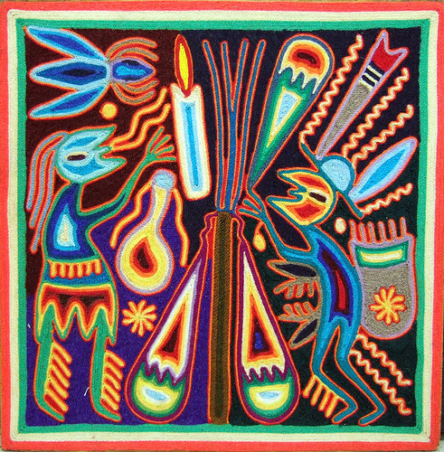
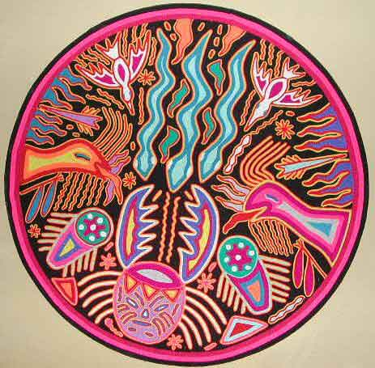
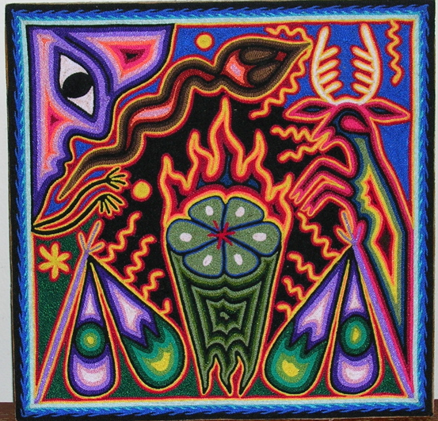
Thumbnail #1
Thumbnail #3
Thumbnail #2

*Be sure to show Ms. Denison your three designs to help you choose the best one to do for your project.

