Notan Is a Design Element used for creating composition in art. The Japanese use the term 'Notan' to describe an important element of design. This concept involves the play of light versus dark. Notan means dark versus light harmony.
------------------- Positive Negative Space -------------------------------------
STEPS TO FOLLOW:
- First, the teacher will introduce masks of Latin America focusing on Aztec, Mayan, and Mexican masks.
- Next, you will use these examples as inspiration for drawing at least 2 thumbnail sketches for your own mask in your sketchbook.
- You will need to decide if your mask will be vertical or horizontal.
- Then, you will get a full sheet of white card stock and a ½ sheet of colored card stock. (Choose ½ vertical or ½ horizontal.)
- You will then draw out your design on the colored card stock.
- Carefully cut out each piece and flip over the central axis. (lay it out before gluing down on the paper.)
- Continue until the entire mask is complete. (Don’t loose pieces. Get a paperclip to keep them all together in your portfolio.)
- Then grade yourself on the rubric and turn in to the class box.

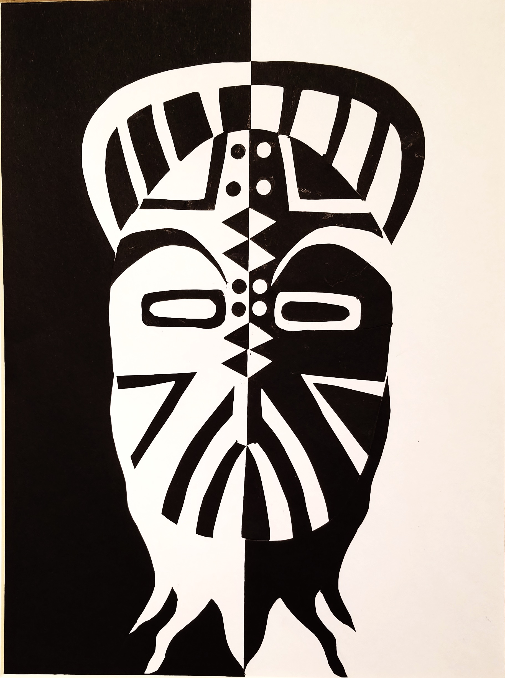

Student Name:

Lesson: Notan Tribal Mask
Circle the number in pencil that best shows how well you feel that you completed that criterion for the assignment. |  | Excellent | Good | Average | Needs Improvement
Criteria 1 – Composition: Successfully created a unique and interesting mask inspired by the masks of Latin and South America. Mask has some decorative details within. |  | 10 | 9 – 8 | 7 | 6 or less
Criteria 2 – Symmetrical Balance: Successfully placed positive and negative colors across the central axis so that it lines up to be perfectly balanced. |  | 10 | 9 – 8 | 7 | 6 or less
Criteria 3 – Cutting technique. Student successfully used an exacto knife to cut out the designs. The edges were pristine and clear instead of jagged and rough. |  | 10 | 9 – 8 | 7 | 6 or less
Criteria 4– Effort: took time to develop idea & complete project? (Didn’t rush.) Read the article and followed the steps within. Good use of class time? |  | 10 | 9 – 8 | 7 | 6 or less
Criteria 5 – Craftsmanship – Neat, clean & complete? Skillful use of the art tools & media? |  | 10 | 9 – 8 | 7 | 6 or less
Total: 50  (possible points) /50 pts | Grade:

