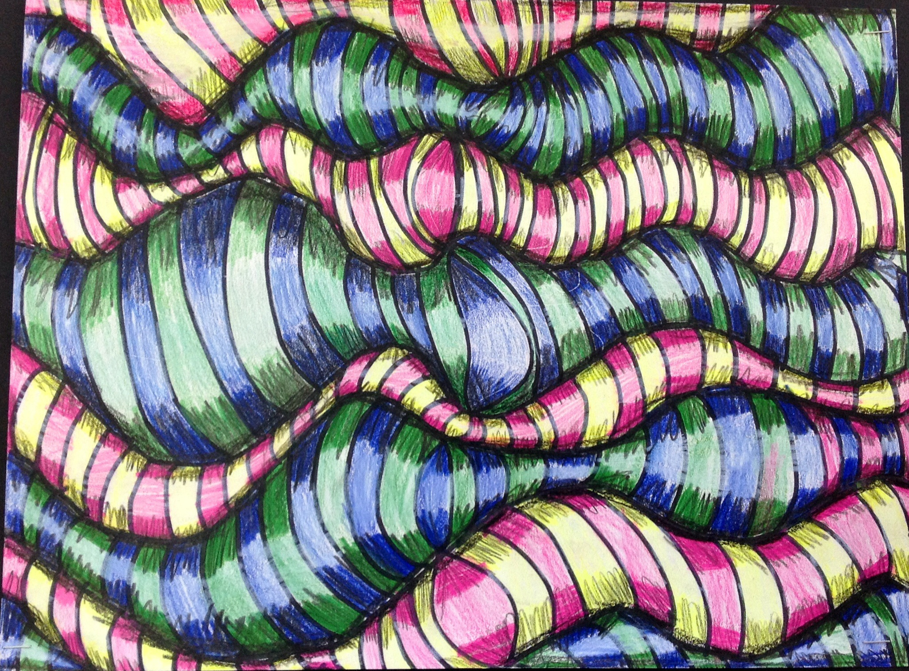
Op art, also known as optical art, is a style of visual art that uses optical illusions.^{[1]}
Op art works are abstract, with many better known pieces created in black and white. Typically, they give the viewer the impression of movement, hidden images, flashing and vibrating patterns, or of swelling or warping.
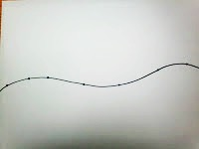
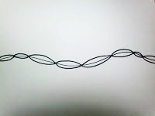
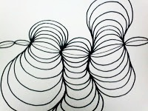
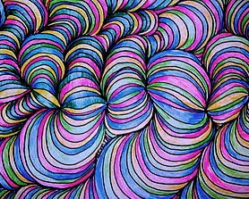
- Start with a gentle curve across the paper.
- Place 8 dots on the line spaced at different distances.
- Go dot-to-dot across the entire line. (Do not continue this, or it will create a boring column strait up and down.)
- As you go dot-to-dot, “camp out” at some segments to let them balloon out or let others get “pinched off” for more interesting effects.
- When complete, add color with watercolor colored pencils, making it darker on the edges and white in the center.

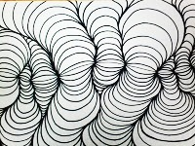

Student Name:

Lesson: Op Art Line Design
Circle the number in pencil that best shows how well you feel that you completed that criterion for the assignment. |  | Excellent | Good | Average | Needs Improvement
Criteria 1 – Composition: interesting spacing with ballooning out and pinched off sections. Avoiding the “column” effect of strait up and down. |  | 10 | 9 – 8 | 7 | 6 or less
Criteria 2 – Line Quality: lines go back to the dots without overlapping, following along all the contours that came before. |  | 10 | 9 – 8 | 7 | 6 or less
Criteria 3 – Shading of color. Student utilized watercolor colored pencils to add shading within the color sections. The edges are darker and the middle of the sections are left white with a gradation of color between them. |  | 10 | 9 – 8 | 7 | 6 or less
Criteria 4 – Effort: took time to develop idea & complete project? (Didn’t rush.) Read the article and followed the steps within. Good use of class time? |  | 10 | 9 – 8 | 7 | 6 or less
Criteria 5 – Craftsmanship – Neat, clean & complete? Skillful use of the art tools & media? |  | 10 | 9 – 8 | 7 | 6 or less
Total: 50  (possible points) /50 pts | Grade:

