Student Name:  Lesson: Patterned Paper Collage |  |  | Class Period:
Circle the number that best shows how well you feel that you completed that criterion for the assignment. |  | Excellent | Good | Average |  | Needs Improvement
Criteria 1 – Composition: The bird is well thought out and fits well into the designed background inspired by Rex Ray and Charlie Harper. |  | 10 | 9 – 8 | 7 |  | 6 or less
Criteria 2 – Patterned Paper Cutout: At least 5 patterned papers used throughout the background and foreground to add good texture and interest. Paper is cut well for each of the shapes needed and neatly put together. |  | 10 | 9 – 8 | 7 |  | 6 or less
Criteria 3 – Background vs. Foreground: Background was glued on first to create depth as a design. Foreground glued last to stand out with the bird. |  | 10 | 9 – 8 | 7 |  | 6 or less
Criteria 4 – Effort: took time to develop idea & complete project? (Didn’t rush.) Good use of class time? |  | 10 | 9 – 8 | 7 |  | 6 or less
Criteria 5 – Craftsmanship – Neat, clean & complete? Skillful use of the art tools & media? |  | 10 | 9 – 8 | 7 |  | 6 or less
Total: 50  (possible points) | Grade: /50 = |  | Your Total |  | Teacher Total
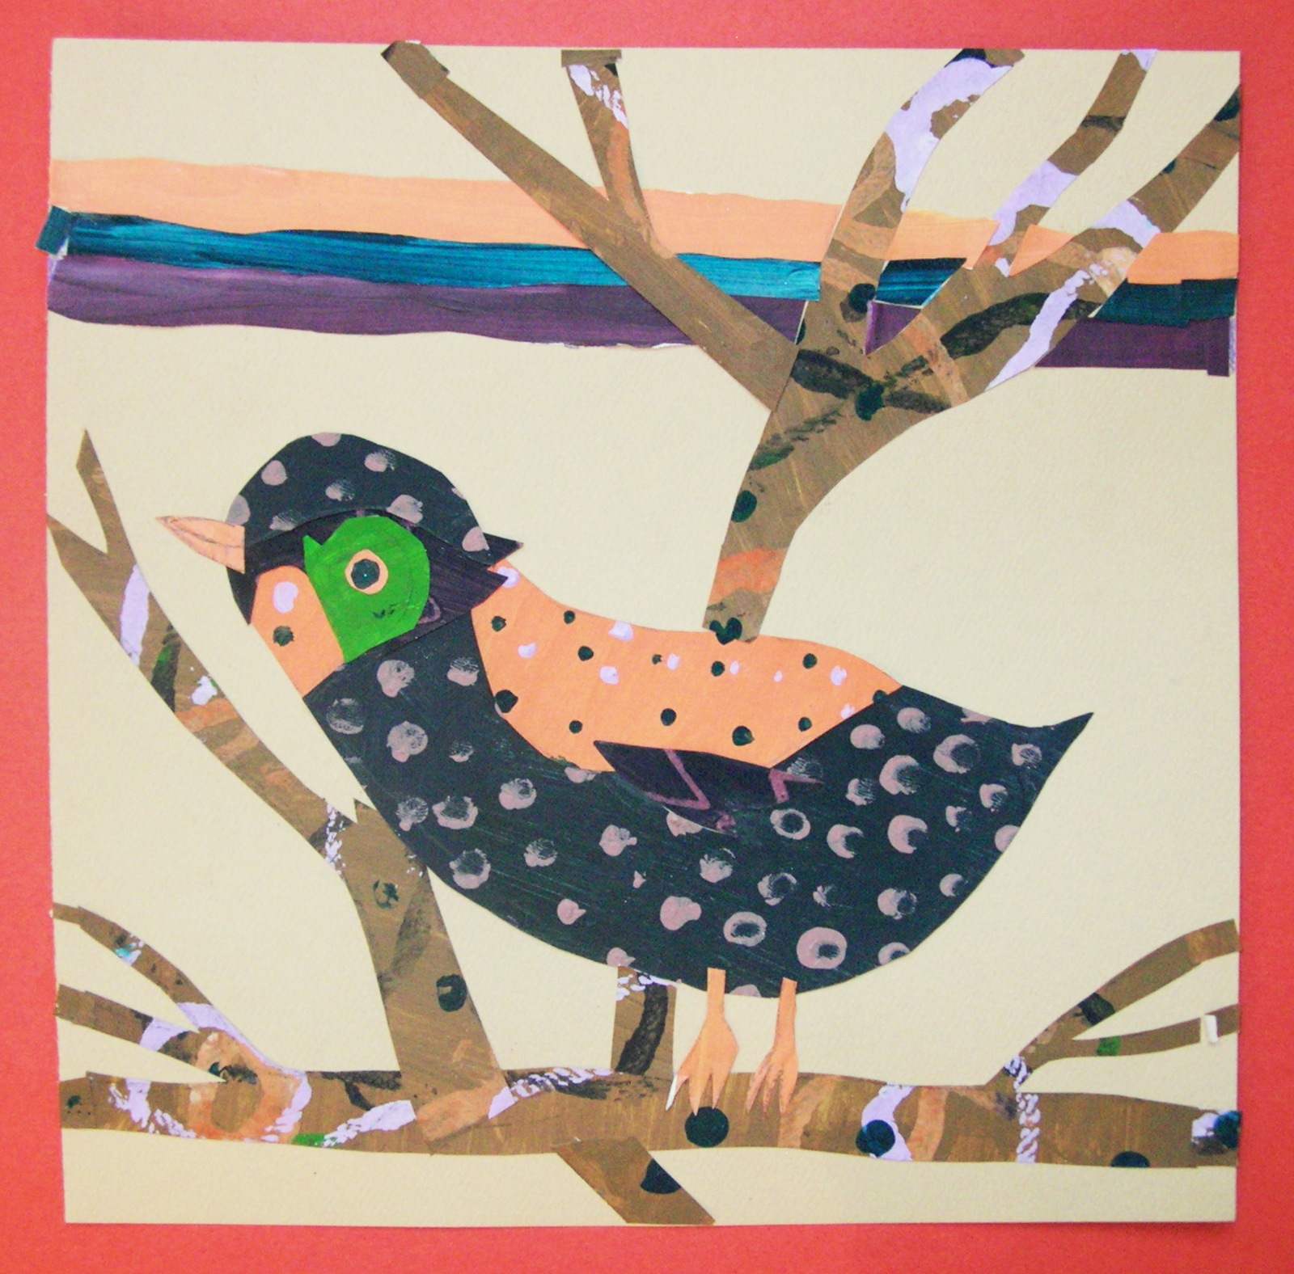
STEPS TO FOLLOW:
- Students will first look through the bird handouts to get ideas for what type of bird they’d like to create with their collage.
- Mrs. Denison will introduce the work of Charlie Harper and the type of birds he creates as well as Rex Rey for his designs.
- Students will then create at least four sheets of patterned paper using paint on colored paper.
- Next, the students will create three thumbnail sketches for their collage.
- Students will then show their best sketch to Mrs. Denison to get their final paper.
- Students will then cut out their birds and designs from the patterned paper and collage them together into one complete design.
- Students will need to glue the BACKGROUND FIRST before gluing foreground elements.
- Students will complete the rubric before turning in final project.

------------ Patterned Paper Collage -------------------------------------

