Paper Roll Relief Sculptures

STEPS TO FOLLOW:

- You will make four quick thumbnail sketches of different ideas for your relief sculptures in your sketchbooks.
- You will then get one thumbnail approved to draw a bigger sketch of in your sketchbook for your final design. This sketch should be more detailed than the thumbnails were.
- You will receive four toilet paper rolls (one paper towel roll= two toilet paper rolls) to begin creating your relief sculpture.
- You will receive four different colored sheets of construction paper at your table. You will choose one to use for the background of your relief sculpture.
- You will create your relief sculpture using the paper rolls and adhere it to your construction paper.
- You will grade yourself on your rubric, attach to the back of your project with a paper clip, and turn it in.

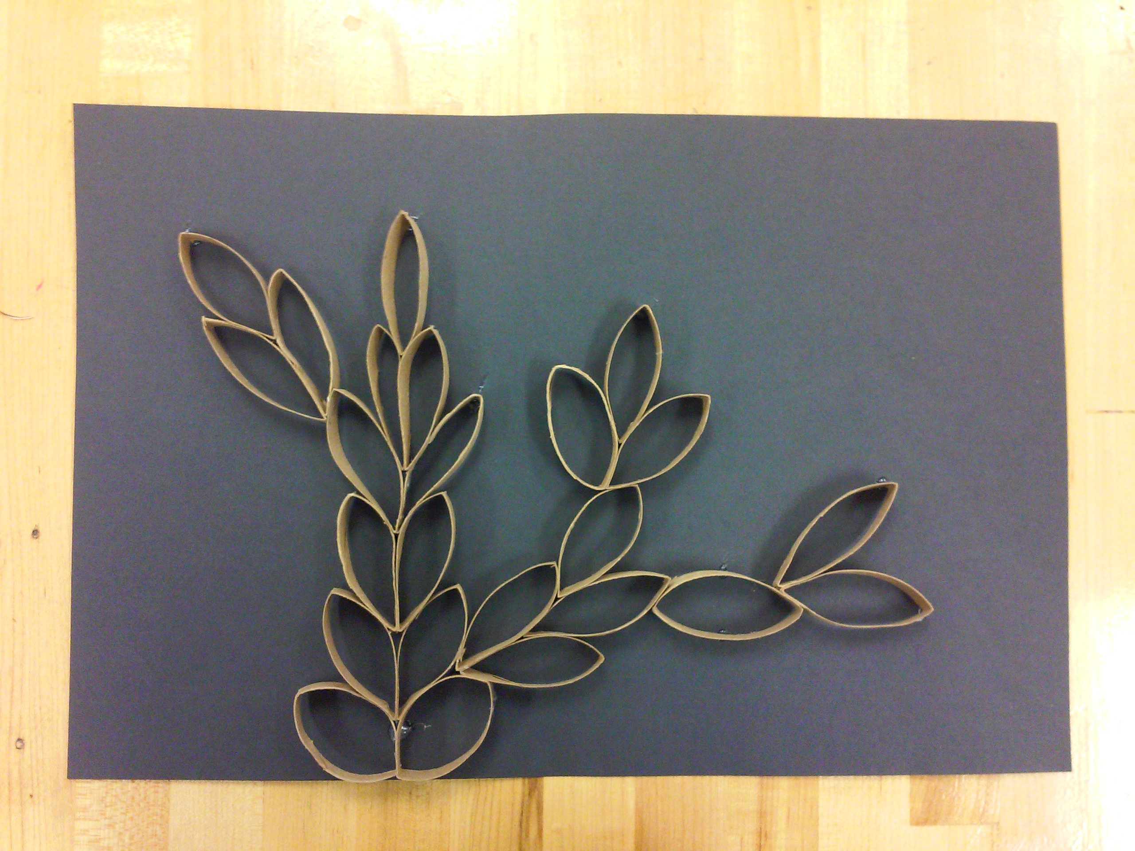

Student Name:

Lesson: Paper Roll Relief Sculptures
Circle the number in pencil that best shows how well you feel that you completed that criterion for the assignment. |  | Excellent | Good | Average | Needs Improvement
Criteria 1 – Uniqueness: Did you use your paper rolls to create a unique composition? Does it look very similar to your classmates, or does it have different elements that make it stand out? |  | 10 | 9 – 8 | 7 | 6 or less
Criteria 2 - Overall Design: How effectively did you put together the paper rolls to create a pleasing composition? |  | 10 | 9 – 8 | 7 | 6 or less
Criteria 3 – Unity/Movement: Do all the paper rolls come together to create one cohesive piece? Are your eyes led around the whole sculpture? |  | 10 | 9 - 8 | 7 | 6 or less
Criteria 4 – Effort: took time to develop idea & complete project? (Didn’t rush.) Read the rubric and followed the steps within. Good use of class time? |  | 10 | 9 – 8 | 7 | 6 or less
Criteria 5 – Craftsmanship – Neat, clean & complete? Skillful use of the art tools & media? |  | 10 | 9 – 8 | 7 | 6 or less
Total: 50 Grade:
(possible points) /50 pts

