STEPS TO FOLLOW:

- You should choose one piece of candy to use for your project. This piece of candy needs to be kept whole and packaged until the project is completed, and kept in cubbies when not in class.
- You will draw 4 thumbnail sketches of your candy in your sketchbooks. The candy shouldn’t be drawn centered in the thumbnail square – a more interesting composition can be angled, cropped, zoomed-in, etc.
- You should choose one of your thumbnails to be your final design. This should be approved by Ms. Ibrahimi before given the paper for your final draft.
- You will redraw your approved design onto the square sheet of paper. Rulers should be used for straight edges. Ms. Ibrahimi should approve of the final design before continuing.
- You will paint your design. You should use the same colors as the candy wrapper to demonstrate the Pop Art style’s imagery from popular culture.

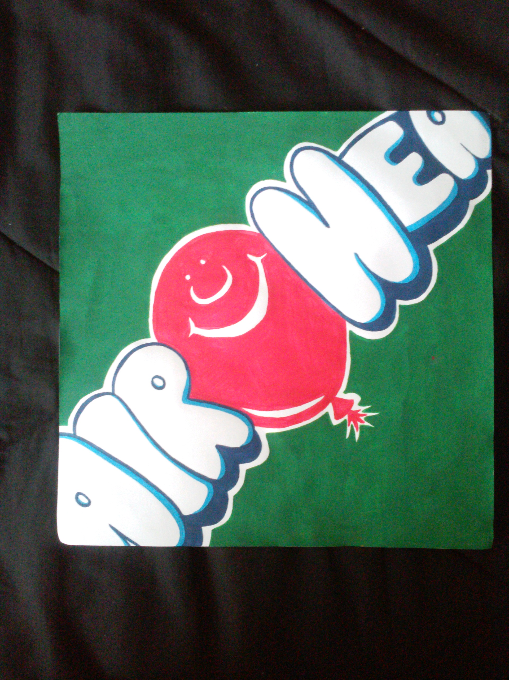

Student Name:

Lesson: Pop Art Candy Paintings
Circle the number in pencil that best shows how well you feel that you completed that criterion for the assignment. |  | Excellent | Good | Average | Needs Improvement
Criteria 1 – Pop Art Imagery of Popular Culture: Does the painting look like a replication of the candy product? Does it correctly advertise it?  Criteria 2 - Color: Are the colors mirroring the product's colors? Are colors mixed well? |  | 10 | 9 – 8 | 7 | 6 or less
Criteria 3 – Composition: Is the composition interesting (angles, crops, zooms, etc.), or is the candy just centered in the page? |  | 10 | 9 – 8 | 7 | 6 or less
Criteria 4 – Effort: took time to develop idea & complete project? (Didn’t rush.) Read the rubric and followed the steps within. Good use of class time? |  | 10 | 9 – 8 | 7 | 6 or less
Criteria 5 – Craftsmanship – Neat, clean & complete? Skillful use of the art tools & media? |  | 10 | 9 – 8 | 7 | 6 or less
Total: 50 Grade:
(possible points) /50 pts

