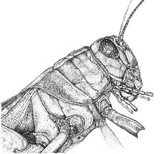

------------- INSECT/FLOWER LINOCUT-------------------------------------
STEPS TO FOLLOW:
- Get ideas from insect and flower images and create 3 thumbnail sketches on the back.
- Next, Mrs. Denison will check your best design to create a 4x6 rough draft. You will shade it in to get an idea of how it will look in black and white.
- Then, you will transfer your original design onto the 4x6 linoleum block.
- Once you design is drawn out, you will carve out the WHITE areas using the Linoleum cutting tools.
- Once you have carved out all the white, you will then begin printing. (see Mrs. Denison’s demo)
- You will need to turn in an edition of 4 good quality prints, which should be numbered and signed.
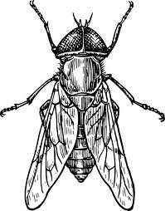
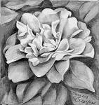
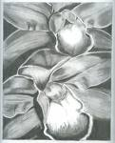

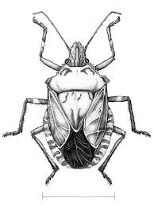

Student Name:  Lesson: Floral/ Insect Printmaking |  |  |  |  |  | Class Period:
Circle the number in pencil that best shows how well you feel that you completed that criterion for the assignment. |  | Excellent | Good | Average | Needs Improvement | Rate Yourself | Teacher’s Rating
Criteria 1 – Design/ Composition: Floral/ Insect design used and filled printed area. There is about 50/50 white to black ratio within the design. |  | 10 | 9 – 8 | 7 | 6 or less
Criteria 2 – Carving technique: Used a variety of gouges to create linear movement in the flower or insect design. The carving should create a variety of values within the image. |  | 10 | 9 – 8 | 7 | 6 or less
Criteria 3 – Printing Technique – Print is evenly covered with ink. (not too much or too little ink used) Print is registered carefully in the center of the paper. |  | 10 | 9 – 8 | 7 | 6 or less
Criteria 4 – Effort: took time to develop idea & complete project? (Didn’t rush.) Good use of class time? |  | 10 | 9 – 8 | 7 | 6 or less
Criteria 5 – Craftsmanship – Neat, clean & complete? Skillful use of the art tools & media? |  | 10 | 9 – 8 | 7 | 6 or less
Total: 50  (possible points) | Grade: |  |  |  |  | Your Total | Teacher Total

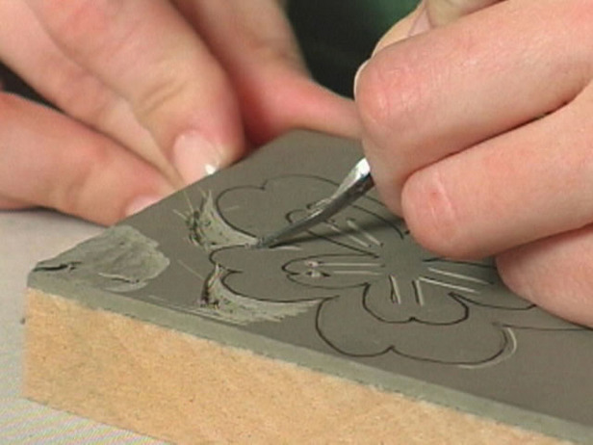
Fig 1: Three thumbnail sketches of flowers or insects. You will shade your best one to see which areas will be black or white on your print.

Fig 2: Once your design is drawn into the linoleum, you will cut out the WHITE areas using the linoleum cutting tools.

Fig 3 & 4: You will use the print block to create an edition of 4 QUALITY prints to turn in. You may print more, but you can only turn in 4.
Fig. 1

Fig. 2

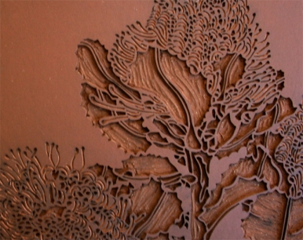
Printmaking Vocabulary
Edition: a series of prints made form the same plate
Proof: the first print made from a plate (not part of the edition)
Relief Printing: printing from a raised or depressed surface example: potato printing, rubber stamps, thumbprints
Plate: a flat surface used for printing - the image will be backwards on it
Brayer: a small roller used to apply the ink to the plate
Baren: an instrument used to create pressure between the plate, ink and paper
U-Gouge: tool that cuts out larger areas
V-Gouge: tool that cuts out finer lines

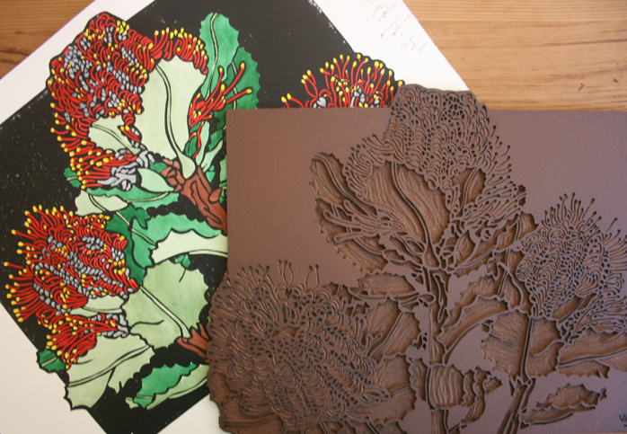
Fig. 3 & 4

