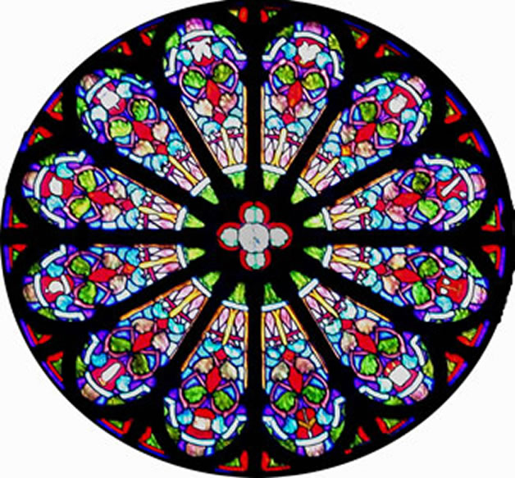

Steps to Follow:

1. Draw your name in a creative way inside your triangle.
2. Outline on both sides with sharpie.
3. Trace four times on 6” square paper to create ¼ of your finished radial design. Make sure to flip your triangle each time you trace.
4. Outline both sides of you square with sharpie.
5. Trace your square four times to complete the larger 12” square. Flip your square each time you trace. Your finished design will be symmetrical both vertically and horizontally.
6. Outline your finished design with sharpie (one side only).
7. Choose your color scheme.
8. Add color to your radial design using your color scheme and tints and shades.
9. Use interesting colored pencil coloring techniques- shade, blend and layer.

You are creating a radial design with the elements of line and shape. Using a color scheme, you will add color to your design. Remember to use tints and shades, blend your colors, and fade the color from light to dark in areas. This will create interest and make your design more appealing to look at.

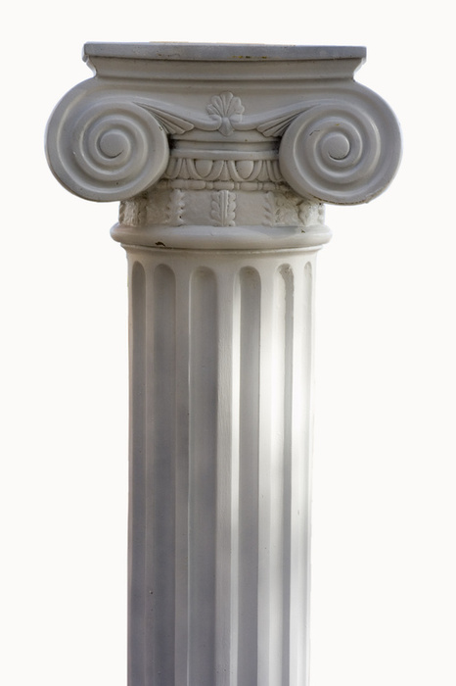

I am using a __________________ color scheme.

The following colors are part of my color scheme (minimum of 5 colors must be used).

       

WARM-

COOL-

MONOCHROMATIC-

ANALOGOUS-

COMPLEMENTARY-

Define the following color schemes.

**Complete the Self Assesment**

|  |  |  |  |  |  |  |
| --- | --- | --- | --- | --- | --- | --- |
| **Student Name:**  **Lesson: Radial Balance Color Project** | | | **Class Period:** | | | |
| Circle the number that best shows how well you feel that you completed that criterion for the assignment. | | **Excellent** | **Good** | **Average** | | **Needs Improvement** |
| **Criteria 1** – **Design/ Composition**: Design is intricate and flows from one quadrant to the next. Square is completely filled with design. | | 10 | 9 – 8 | 7 | | 6 or less |
| **Criteria 2** – **Color Application/ Success of Color Scheme**: Color scheme used.. Design contains at least one tint, one shade, and one tone within the color scheme. | | 10 | 9 – 8 | 7 | | 6 or less |
| **Criteria 3** – **Painting Technique** – Paint has been applied so that design is still visible. The paint technique used helps to enhance the overall design. | | 10 | 9 – 8 | 7 | | 6 or less |
| **Criteria 4** – **Effort**: took **time** to develop idea & complete project? (Didn’t rush.) Good use of class time? | | 10 | 9 – 8 | 7 | | 6 or less |
| **Criteria 5** – **Craftsmanship** – Neat, clean & complete? Skillful use of the art tools & media? | | 10 | 9 – 8 | 7 | | 6 or less |
| **Total: 50**  (possible points) | **Grade:** /50 = | | **Your Total** | | Teacher Total | |