Would you like a sketchbook?
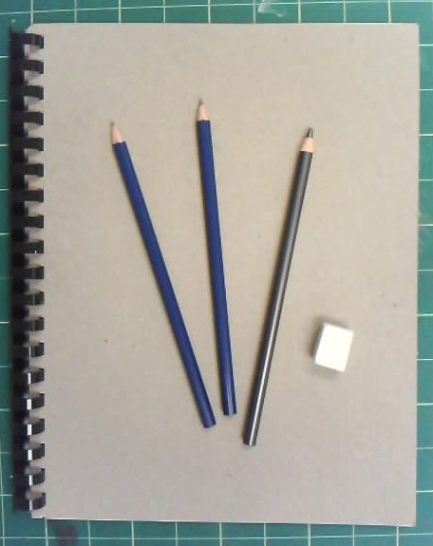
The Lost Mountain Visual Arts Department
Presents:

THE SKETCHBOOK SALE!

This is your opportunity to buy a good sketchbook at a reduced cost from the average art or supply store, and proceeds of the sales will go to support Lost Mountain Visual Arts Students!

Order forms should be turned in to Mrs. Denison, Room 149.
Payment envelopes must be placed in a black lock box.
We are offering one of two packages for sketchbooks:

Package A: Includes an 8 ½ x 11 inch sketchbook for $5.00.
Package B: Includes the 8 ½ x 11 inch sketchbook, 3 drawing pencils, and an eraser for $10.00

If you would like to order either of these packages, please fill out the form below and hand it in to Mrs. Denison in room 149. Payment can be made in cash or check and placed in a payment envelope. These should be put into one of the secured black boxes in the school. Checks should be made out to Lost Mountain Middle School.

Student Name: __________________________________________ Package A: ____________ Package B: ______________
(please check one)
Student Homeroom: ______________________________________________
*Sketchbook packages will be delivered to students 24-48 hours after receiving the payment.

