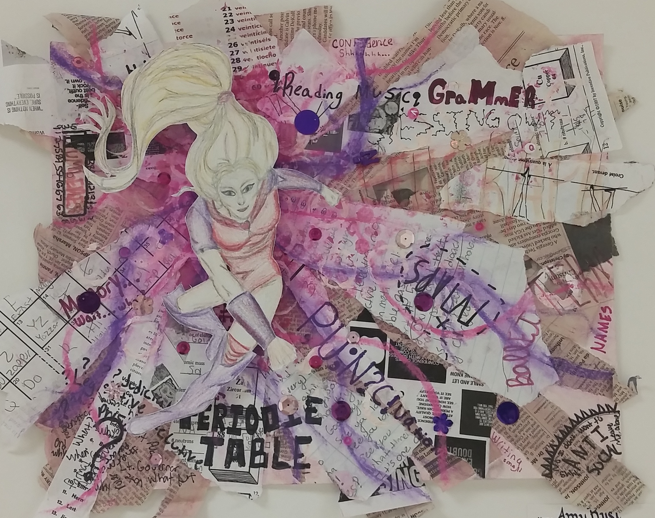
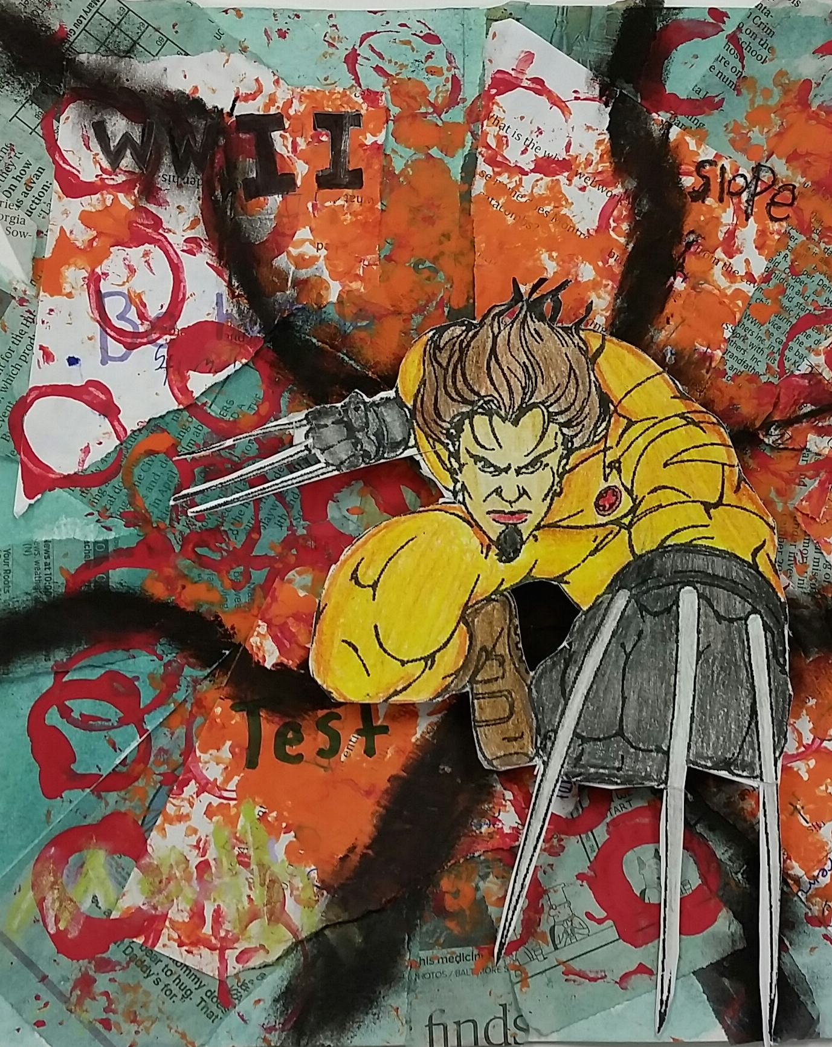
Your Challenge:

- Come up with an area that is a struggle for you or for someone you care about. (This could be with academics, social, connections classes, etc.)

- Create a mixed media composition that uses items from your challenge as a part of the background. (you will add LOTS of layers, collage items, text, etc. for your composition.)

- Create a “superhero” to be a talisman to ward off the challenges you face within your composition. (This will become the focal point within the artwork)

Bring In:

- Any items that relate to your “struggle” topic.
- Old Class notes
- Math formulas
- A tough piece of music
- Geography Maps
- Quotes from literature
- Science concepts
- Sample Business letter format
- Health Topics
Superhero Talisman
A talisman is an object which is believed to contain certain magical or sacramental properties which would provide good luck for the possessor or possibly offer protection from evil or harm.^{[1]}
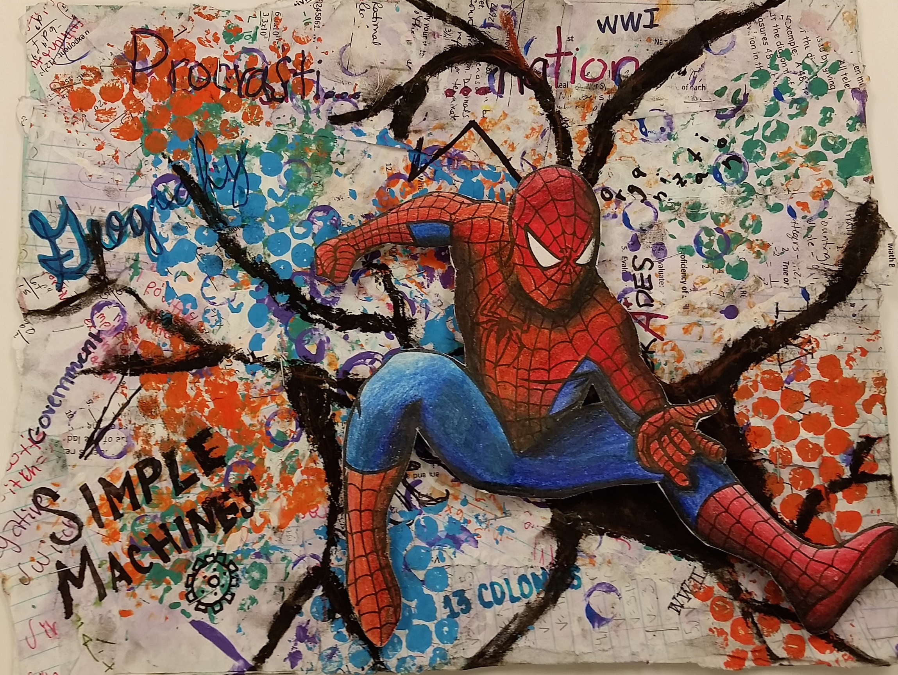
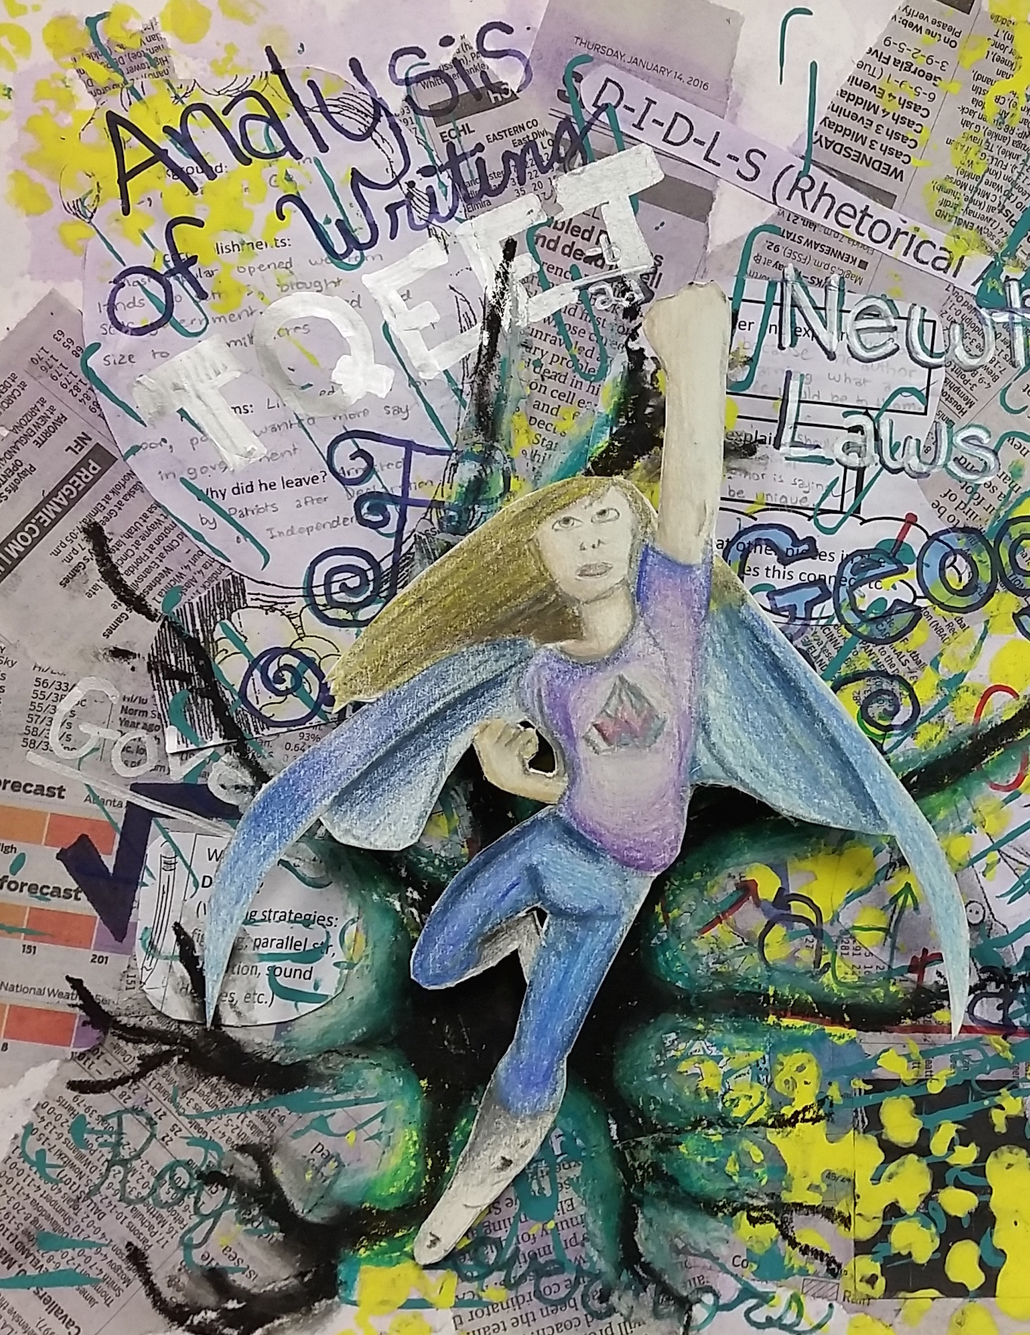
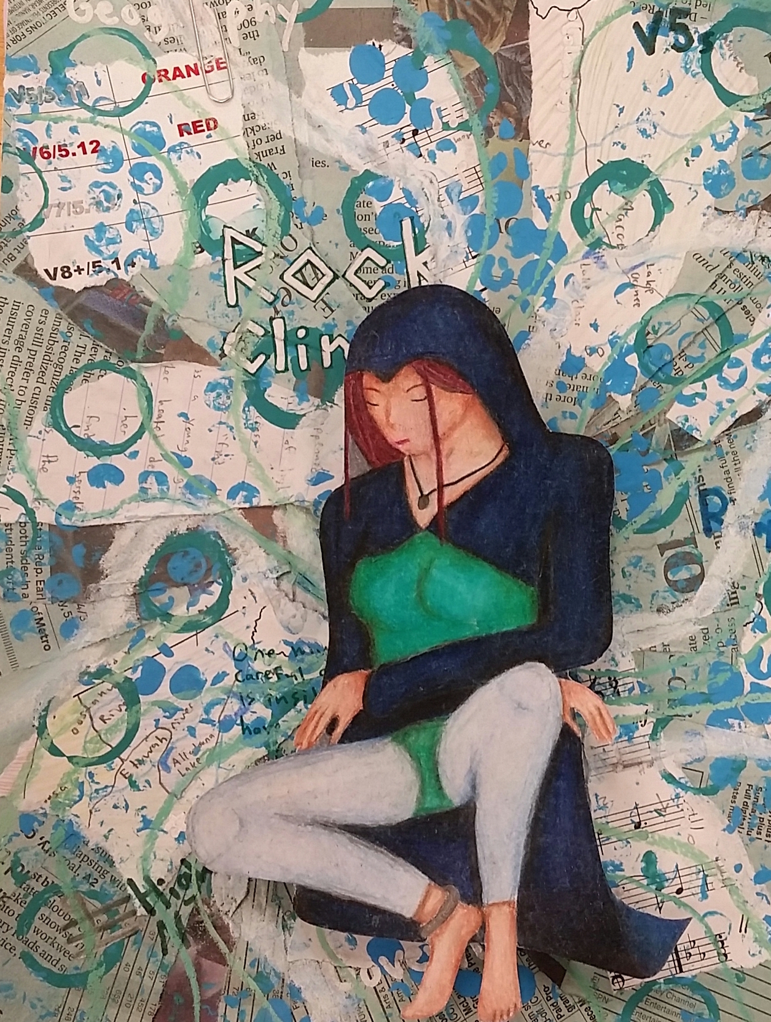
The Hero/ Talisman

You will create your own superhero, or talisman, as a protector to help you overcome the challenge you chose to portray within your composition. You will add color/ shading to give him or her form. This will be the focal point of the composition and you will make him/ her pop out using layered foam core or cardboard.
Layer, Layer, Layer!!
The trick for successful mixed media pieces like this is layering different media to create depth.
Ideas for layering:
Newsprint, stamping textures, Collage elements, transparent glazes, writing text, found 3D items.
Student Name:

Lesson: Superhero Talisman
Circle the number in pencil that best shows how well you feel that you completed that criterion for the assignment. |  | Excellent | Good | Average | Needs Improvement
Criteria 1 – Composition/ Layers: Overall composition is well thought out with multiple layers (at least 3 layers.) Nothing is too clustered on top of one another and there is not too much negative space either. |  | 10 | 9 – 8 | 7 | 6 or less
Criteria 2 – Superhero Talisman: the superhero created is shaded with color to give a sense of form. He/ She is the main focal point of the artwork (large focus, but not in the direct center.) |  | 10 | 9 – 8 | 7 | 6 or less
Criteria 3 – Background lines/text: The background includes lines and text that lead your eye to the main focal point. Shading behind talisman helps give it a “pop.” |  | 10 | 9 – 8 | 7 | 6 or less
Criteria 4 – Effort: took time to develop idea & complete project? (Didn’t rush.) Good use of class time? |  | 10 | 9 – 8 | 7 | 6 or less
Criteria 5 – Craftsmanship – Neat, clean & complete? Skillful use of the art tools & media? |  | 10 | 9 – 8 | 7 | 6 or less
Total: 50  (possible points) /50 pts | Grade:

