---------- contour line, texture, & watercolor -------------------------------------

STEPS TO FOLLOW:
- Create a view finder from a template.
- Use your view finder to create 2-3 thumbnail sketches of different composition of the still life. (Use the rule of thirds to find the focal point in the composition.)
- After deciding on the final composition, use your pencil as a measuring tool for accurate proportions and draw the contour lines accurately on the final paper.
- Make a texture-rubbing index of 10 textures with colored pencil on white paper. Label each and number. Textures should be as different as possible.
- Outline the drawing in black sharpie.
- On thin paper trace ten shapes to find textures for. Outline 3 small, 2 medium, and 2 large shapes that are in different areas of the still-life drawing.
- Use different colored crayons to create your 10 rubbings.
- Cut out the shapes and glue the rubbing to your drawing.
- Complete the remainder of the painting in watercolor.
- Use 4- 6 watercolor techniques.
- Fill out the rubric below and turn in!

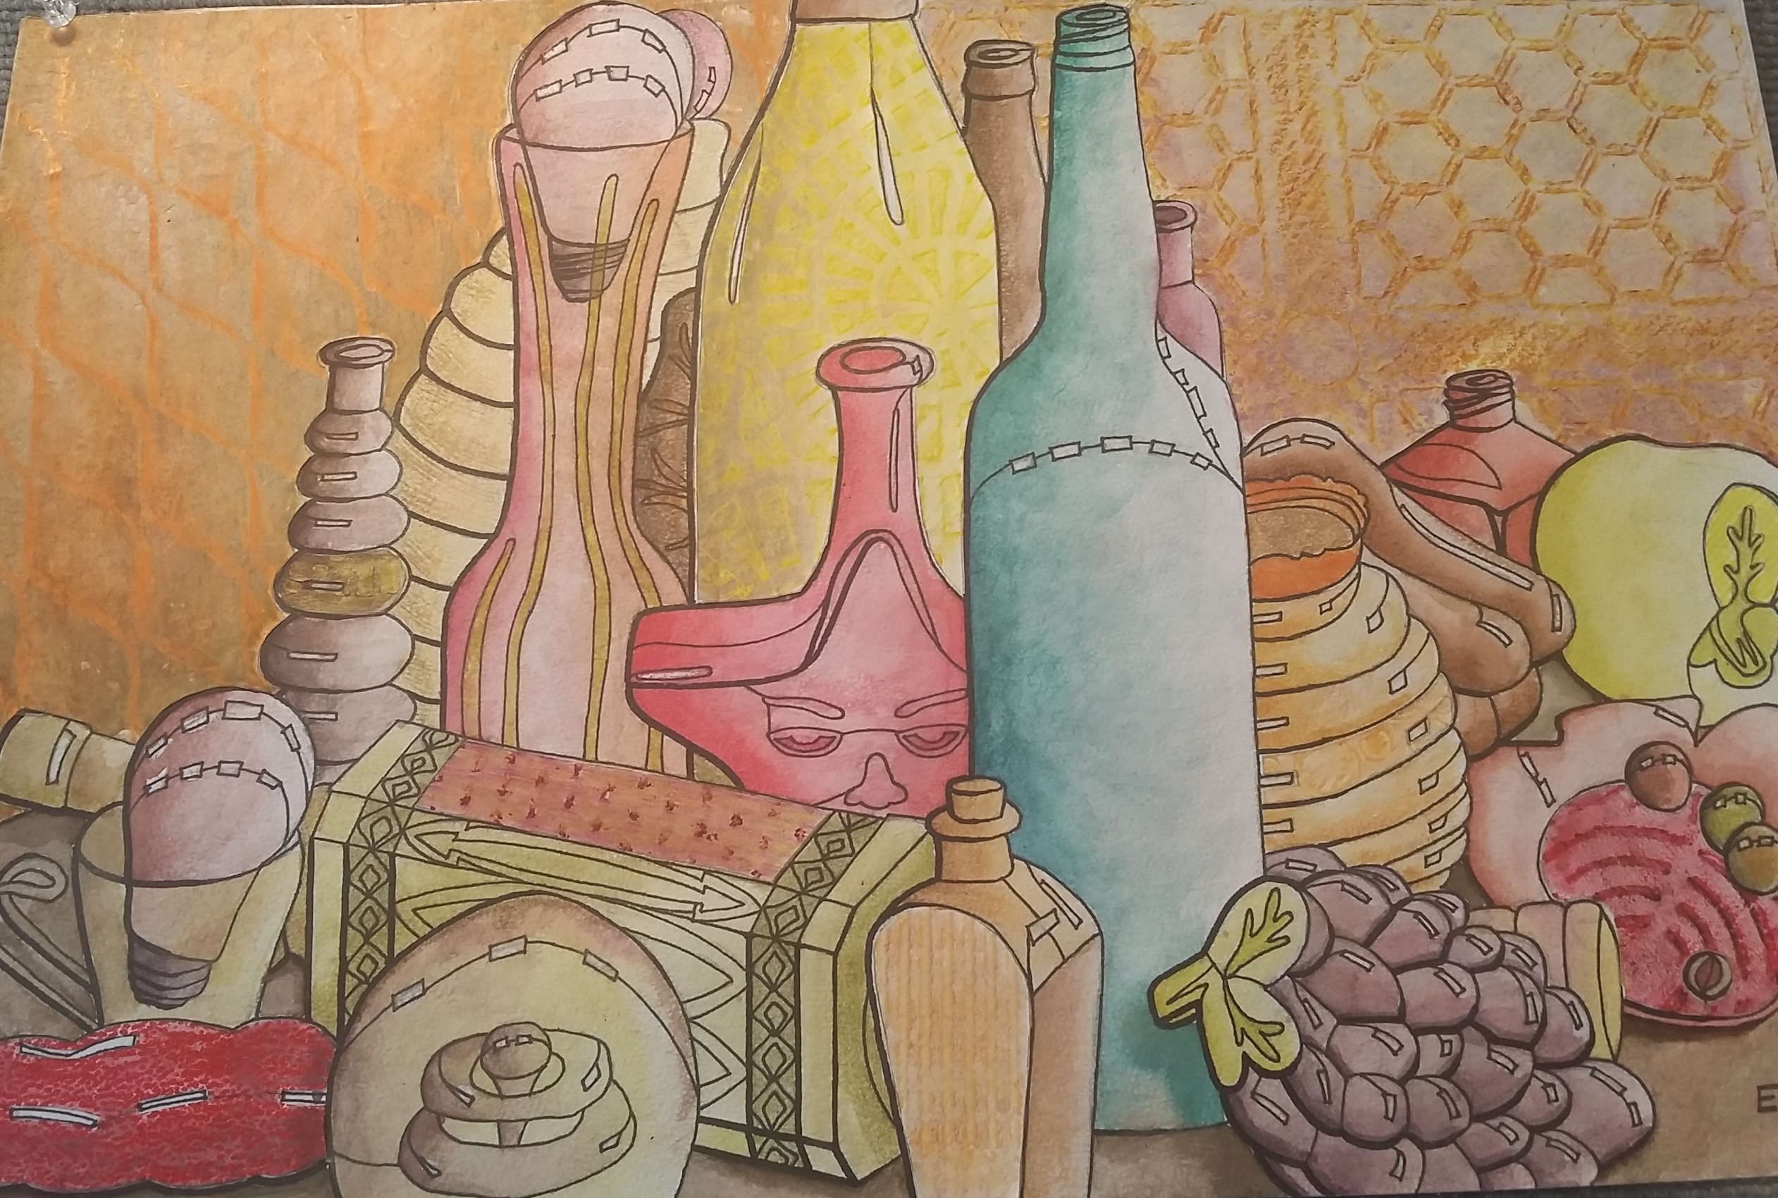

Student Name:

Lesson: Still Life (Contour lines, Texture, and Watercolor)
Circle the number in pencil that best shows how well you feel that you completed that criterion for the assignment. |  | Excellent | Good | Average | Needs Improvement
Criteria 1 – Accuracy of contour lines: Subject matter is successfully enlarged from the still life using the pencil as a measuring tool. Subject is drawn accurately. |  | 10 | 9 – 8 | 7 | 6 or less
Criteria 2 – Composition. Student used a viewfinder to place the subject on the paper in the most interesting way possible. (use rule of thirds) |  | 10 | 9 – 8 | 7 | 6 or less
Criteria 3 – Texture- students successfully found unique textures for at least 7 areas of the drawing. |  | 10 | 9 – 8 | 7 | 6 or less
Criteria 4 –Color choice and VALUES- Student understands the concept of value within each color. Student has chosen a successful color scheme for the composition. |  | 10 | 9 – 8 | 7 | 6 or less
Criteria 5 – Watercolor Techniques- Students successfully used 4-6 different watercolor techniques throughout the painting. |  | 10 | 9 – 8 | 7 | 6 or less
Criteria 6 – Effort & Craftsmanship – took time to develop idea & complete project? (Didn’t rush.) Good use of class time? Neat, clean & complete? Skillful use of the art tools & media? |  | 10 | 9 – 8 | 7 | 6 or less
Total: 60  (possible points) /60 pts | Grade:

