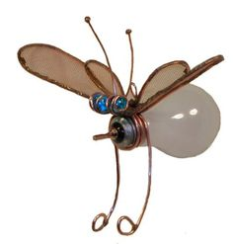

----------Sculptural Critters/ Robots-------------------------------------
Objective: Students will create a sculptural critter or robot using items that would normally go to the landfill.
STEPS TO FOLLOW:

- Collect items for your sculptural assemblage. Anything from old boxes, cans, jars, crates, etc. can be used.

- Put the items together in a way that creates a critter or robot. CREATIVITY IS KEY!!

- FINISHING: decide if you want to add paint, paper, yarn, etc. for finishing touches. Some students may want to spray paint the whole assemblage for uniformity, while others may want the individual parts to show.

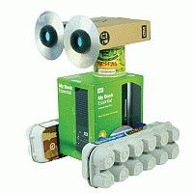

Student Name:

Lesson: Trash to Treasure: Sculptural Critters/ Robots
Circle the number in pencil that best shows how well you feel that you completed that criterion for the assignment. |  | Excellent | Good | Average | Needs Improvement
Criteria 1 – Composition: Successful overall composition of a 3D sculpture from recycled items. Thoughtful finishing to create unity of the overall piece. |  | 10 | 9 – 8 | 7 | 6 or less
Criteria 2 – Use of Elements and Principles: there is thoughtful use of the art elements and principles of design. Student used at least 2 elements and 2 principles within sculpture. |  | 10 | 9 – 8 | 7 | 6 or less
Criteria 3 –Creativity: evidence of creativity and innovation in the artwork and it is genuine, engaging, meaningful and modern. |  | 10 | 9 – 8 | 7 | 6 or less
Criteria 4 – Effort: took time to develop idea & complete project? (Didn’t rush.) Read the article and followed the steps within. Good use of class time? |  | 10 | 9 – 8 | 7 | 6 or less
Criteria 5 – Craftsmanship – Neat, clean & complete? Skillful use of the art tools & media? |  | 10 | 9 – 8 | 7 | 6 or less
Total: 50  (possible points) /50 pts | Grade:

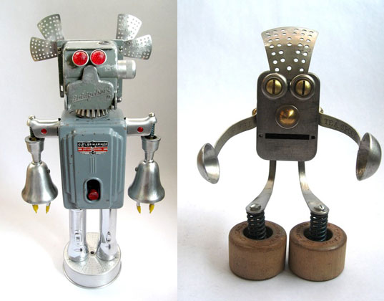
Circle 2 Elements you used: Line, Shape, Form, Texture, Color,
Value, and Space

Explain where/how you used them: _________________________ _____________________________________

Circle 2 Principles you used: Contrast, Movement, Balance, Unity,
Emphasis, Rhythm, and Pattern
Explain where/how you used them: ___________________ _____________________________________

