Student Name:

Lesson: Tropical Reefs Watercolor
Circle the number in pencil that best shows how well you feel that you completed that criterion for the assignment. |  | Excellent | Good | Average | Needs Improvement
Criteria 1 – Composition: Successful overall composition of tropical fish and plants among a tropical reef. |  | 10 | 9 – 8 | 7 | 6 or less
Criteria 2 – Glue Line: Student utilized organic lines covered with glue to create a three-dimensional effect. |  | 10 | 9 – 8 | 7 | 6 or less
Criteria 3 – Watercolor. Student utilized tropical colors with value within the watercolors. |  | 10 | 9 – 8 | 7 | 6 or less
Criteria 4– Effort: took time to develop idea & complete project? (Didn’t rush.) Read the article and followed the steps within. Good use of class time? |  | 10 | 9 – 8 | 7 | 6 or less
Criteria 5 – Craftsmanship – Neat, clean & complete? Skillful use of the art tools & media? |  | 10 | 9 – 8 | 7 | 6 or less
Total: 50  (possible points) /50 pts | Grade:
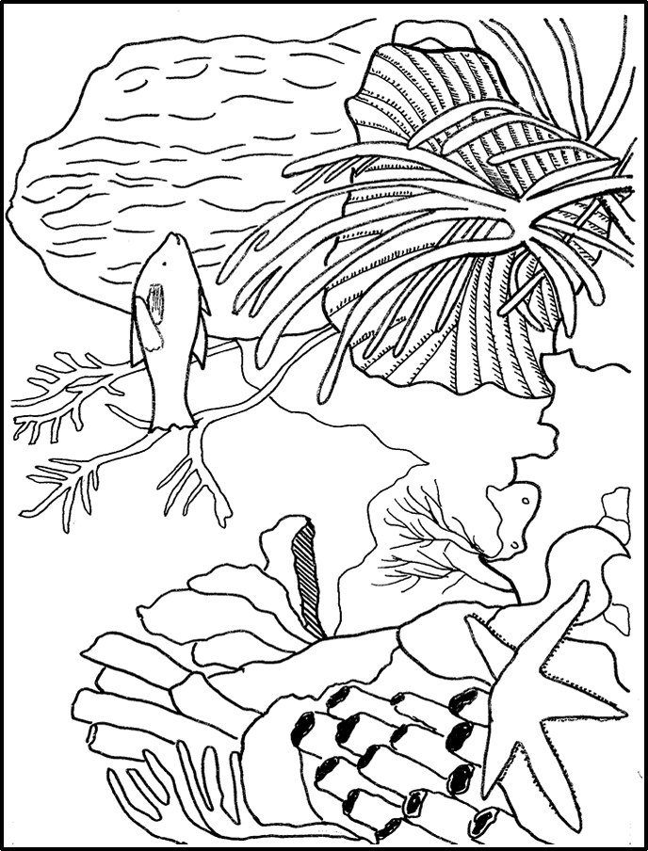

--------- Watercolor & Glue Contours -------------------------------------

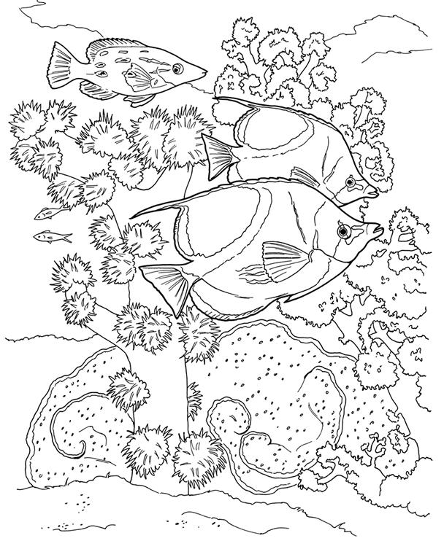
STEPS TO FOLLOW:
- Look through the handouts of sample tropical fish and tropical reefs.
- Create at least three thumbnail sketches of potential compositions on the back of this paper.
- Next, Mrs. Denison will help to pick the best one to put on the 9x12 paper.
- Once the image is sketched out, you will go over your lines with the black glue.
- Once the glue is dry, you will add color using watercolors.
- You will then use the rubric below to grade yourself.

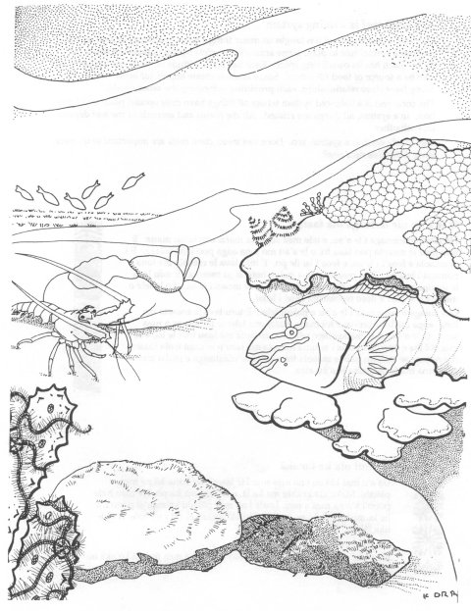
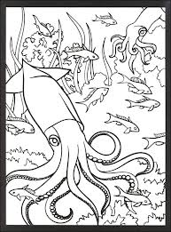
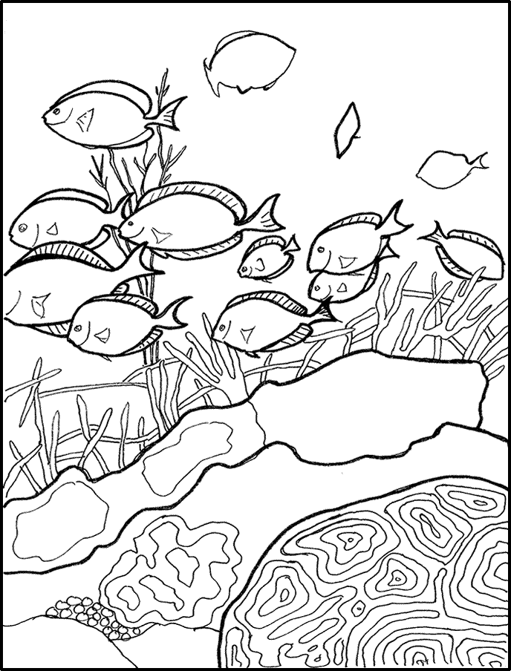

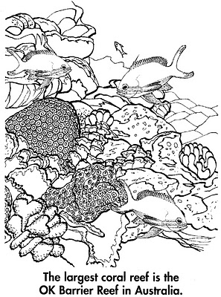
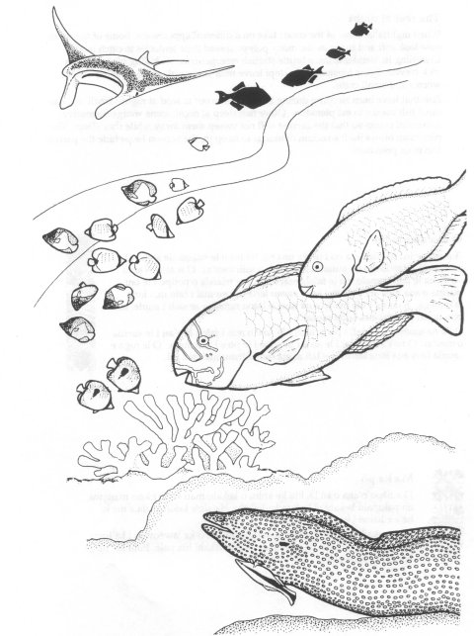
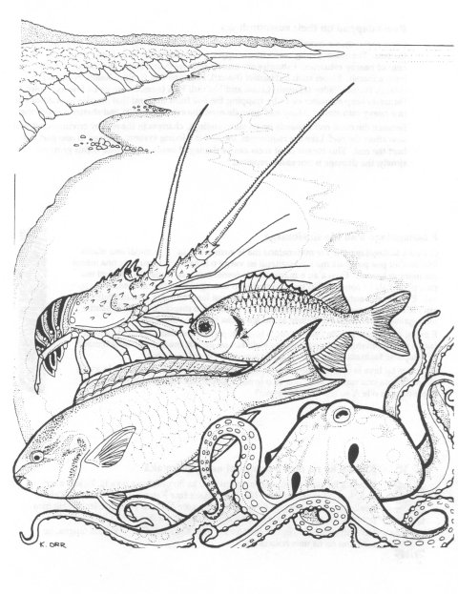
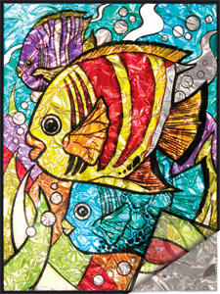

TROPICAL FISH FOIL PAINT BY NUMBER KIT. Royal & Langnickel Painting Kit. Foil Paint By Number Kit includes 6 Translucent Glass Paint Pots, 1 White Paint Pot, 1 Paint Brush, 1 Transparency, 1 Numbered Opaque Underlay, 1 Foil Underlay and easy to follow instructions. Artwork size: 8.25" x 10.25". Foil Paint by Number Kits are unique, fun projects for all artists, inexperienced or experienced! It is a perfect introduction to glass painting! Because the outline has been pre-printed onto the provided transparency, there is no need to worry about subject matter or composition! Just read the instructions and painting tips and you can start painting. Upon completion, place the aluminum foil behind your finished glass painting to accent your display. NOT FOR CHILDREN UNDER 3 YEARS

