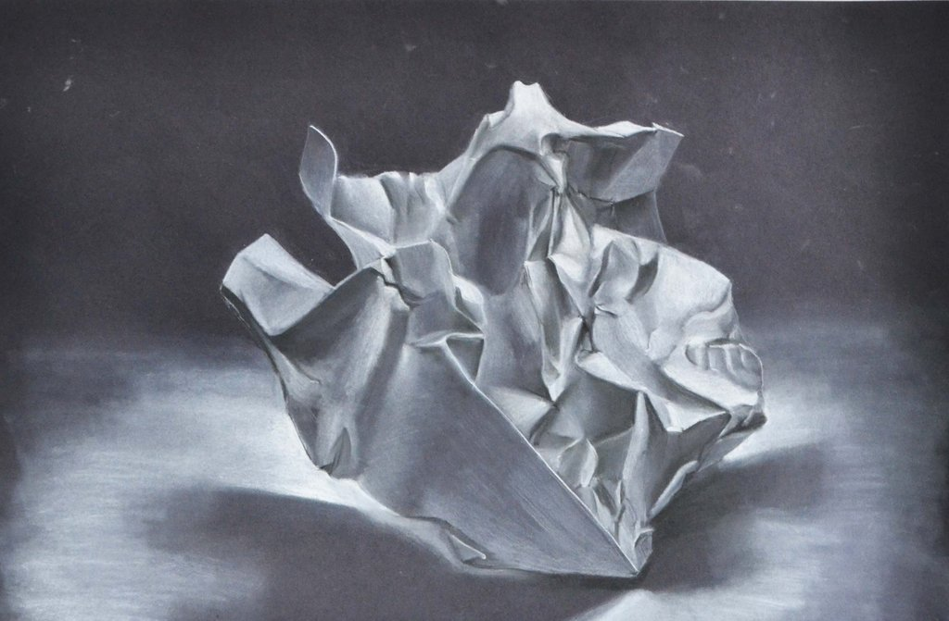

1. Choose 3 pieces of popcorn/paper that you find interesting. Look at their overall shapes. Popcorn is pretty funky looking when you study it as an object and not as a food, don’t you think?
2. **Carefully** set your popcorn/paper of choice onto your small piece white mat board, as you want it to look for your drawing. **Carefully** glue the popcorn/paper down onto the mat board just as you have set it up. I say **CAREFULLY** because popcorn is really super fragile, and you don’t want to break it!!!
3. Next you want to lightly sketch gestures to set up your composition. Then lightly sketch the contours of the popcorn/paper. Use your pencil as a measuring tool. I will be looking for correct proportion, which you can only get from using correct measuring.
4. Now you are ready to shade your popcorn/paper. In this technique of shading, use the black of the paper to leave as the darkest shadows. Use the White charcoal to create at least 6-8 values of darks, lights and mid-tones. **You should have many different tones of value ranging from extreme white to extreme black.**
5. Have fun with this! Take your time, and don’t get frustrated, just keep going…It will turn out wonderful.

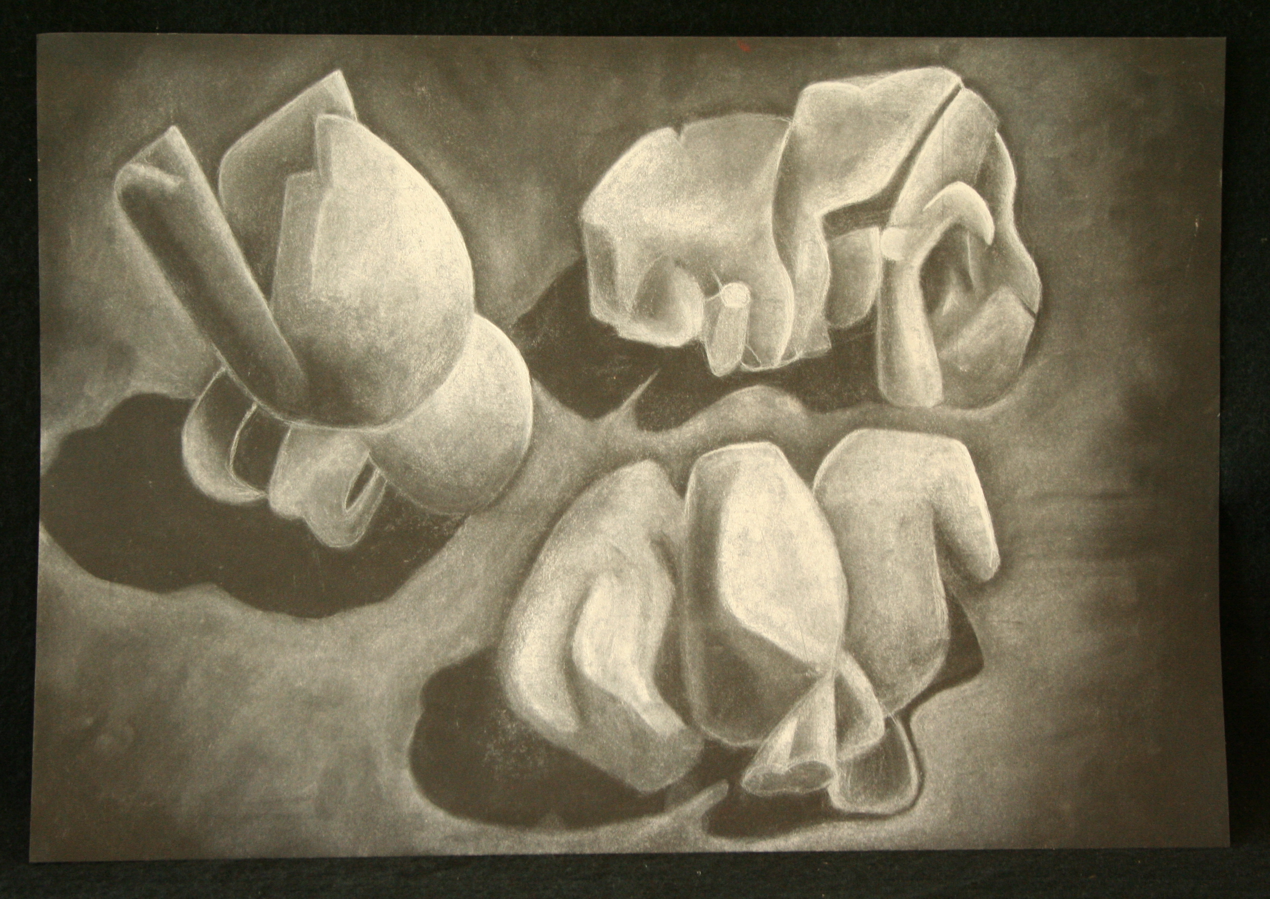

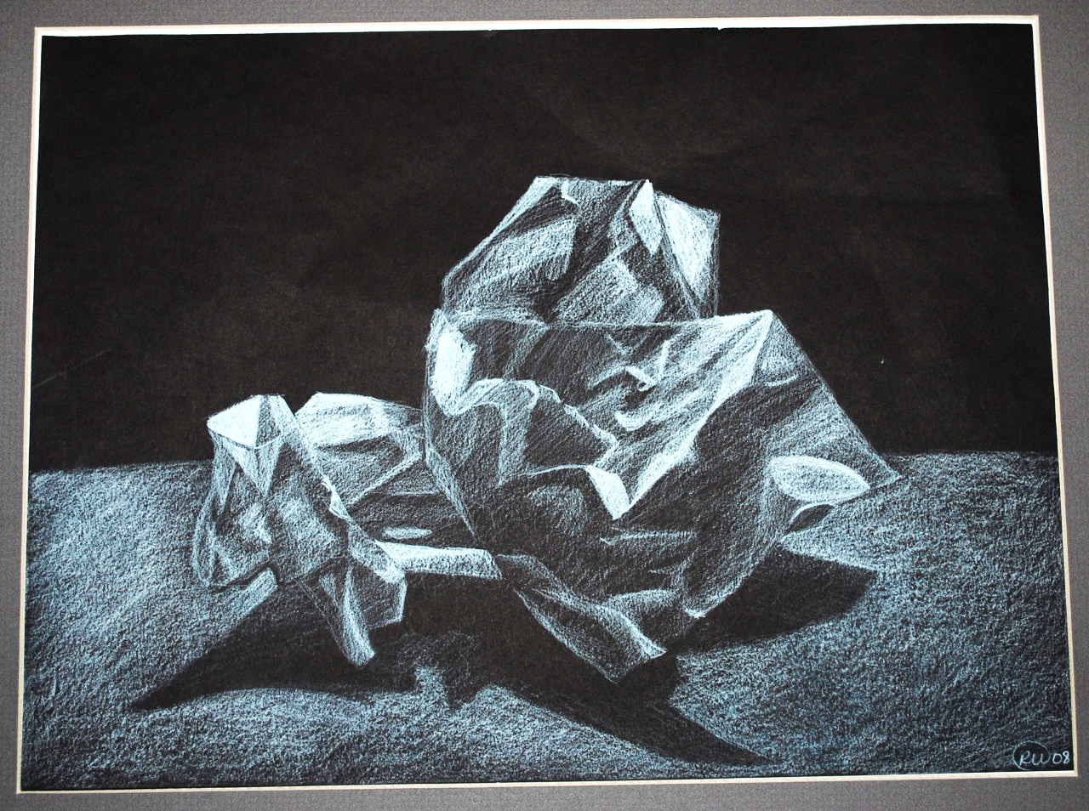

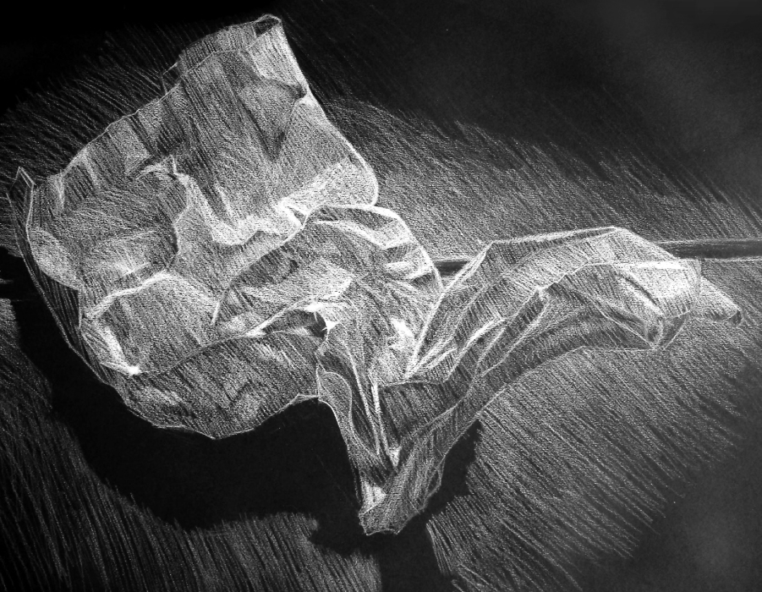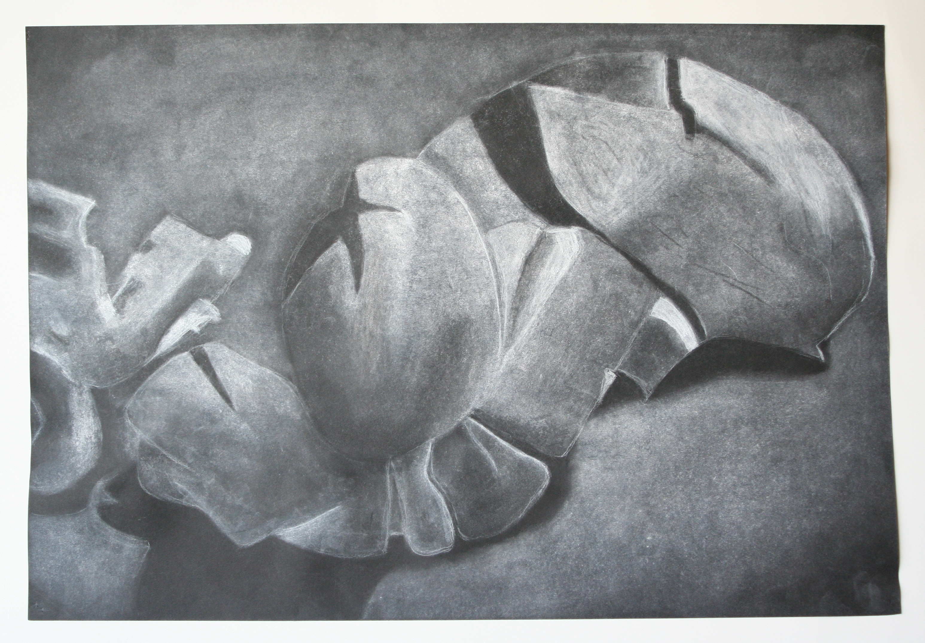

|  |  |  |  |  |  |
| --- | --- | --- | --- | --- | --- |
| **Student Name:**  **Lesson: Value Drawing (popcorn or crumpled paper)** | | | | | |
| Circle the number **in pencil** that best shows how well you feel that you completed that criterion for the assignment. | | Excellent | Good | Average | Needs Improvement |
| **Criteria 1** – **Contours & Accuracy**: Student chose an appropriate subject to draw and successfully enlarged that drawing using the pencil as a measuring tool. Subject is drawn accurately. | | 10 | 9 – 8 | 7 | 6 or less |
| **Criteria 2** – **Values**: Student understands the concept of value in art, and can use Charcoal and black paper to express a full range of values (6-8) from white, to light gray, dark gray, and black. Completed drawing shows that range. | | 10 | 9 – 8 | 7 | 6 or less |
| **Criteria 3** –  **Composition**. Still life was set up in an interesting way. The subject is placed on the paper in the most interesting way possible. (Used gesture drawing to begin.) | | 10 | 9 – 8 | 7 | 6 or less |
| **Criteria 4** – **Effort**: took **time** to develop idea & complete project? (Didn’t rush.) Good use of class time? | | 10 | 9 – 8 | 7 | 6 or less |
| **Criteria 5** – **Craftsmanship** – Neat, clean & complete? Skillful use of the art tools & media? | | 10 | 9 – 8 | 7 | 6 or less |
| **Total: 50**  (possible points) | **Grade:** |  |  |  |  |