**With Art I Can…**

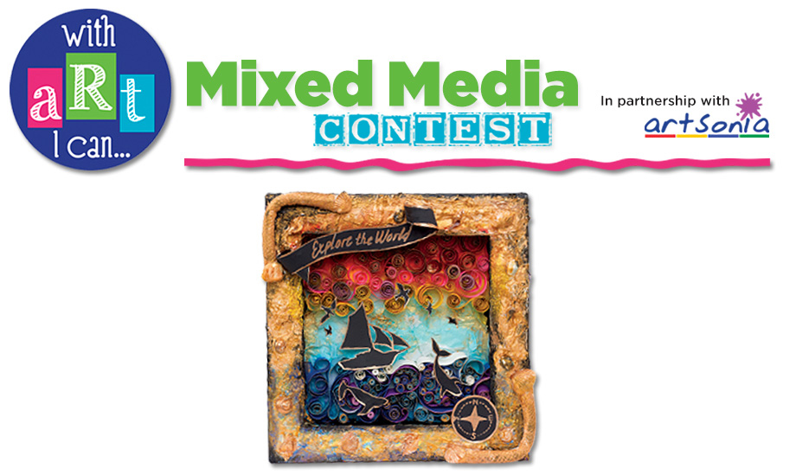

**SELECT YOUR ART**

Shrines can be created to honor a source of inspiration and admiration. For our project, we are going to think about the arts in our lives. Think about some of the possible arts as a subject matter:

* Visual Art
* Music
* Drama
* Design
* Dance
* Opera
* Literature
* Writing or Journaling
* Folk and Traditional Art
* Theater or Musical Theater



* Brainstorm a list of objects that you associate with your subject.
* Brainstorm a list of words that pop into your head when you think of your subject
* Research quotes by or about your subject

Search for and print images that relate to your subject.

An Artist’s Statement that completes the sentence "With Art I Can..." (not to exceed 50 words) must accompany the artwork.

**COLLECT YOUR MATERIALS**

* Images related to the Art you are honoring
* Quotes about the subject
* Rhinestones, beads, charms, etc.
* Glass pebbles
* Glitter
* Tiny mirrors
* Basic crafts supplies, glue, scissors, toothpicks, decorative papers, ribbon, etc.



**ASSEMBLE THE SHRINE**

1. Sand the entire tin so that glue and paint will stick to the metal.
2. Add a background paper and tint with watercolor.
3. Adhere a photo or image of the theme inside the box or tin.
4. Add embellishments if desired: beads, glass pebbles, words, charms,etc.
5. Paint or cover the outside of the box or tin; let dry if needed
6. Embellish the outside as well.

Artist Statement: (Complete the sentence)

With art I can…

|  |  |  |  |  |  |
| --- | --- | --- | --- | --- | --- |
| **Student Name:** | | |  | | |
| Assignment: **Altoid Shrine** | | |  | | |
| Circle the number **in pencil** that best shows how well you feel that you completed that criterion for the assignment. | | **Excellent** | **Good** | **Average** | **Needs Improvement** |
| **Criteria 1** – Artist Statement and theme expressed within the assemblage. | | 10 | 9 – 8 | 7 | 6 or less |
| **Criteria 2** –  Overall Design of assemblage - use of elements and principles of design | | 10 | 9 – 8 | 7 | 6 or less |
| **Criteria 3** – Background- layers used to create depth and interest. | | 10 | 9 – 8 | 7 | 6 or less |
| **Criteria 4** – **Effort**: took **time** to develop idea & complete project? (Didn’t rush.) Good use of class time? | | 10 | 9 – 8 | 7 | 6 or less |
| **Criteria 5** – **Craftsmanship** – Neat, clean & complete? Skillful use of the art tools & media? | | 10 | 9 – 8 | 7 | 6 or less |
| **Total: 50** (possible points) |  |  |  |  |  |

**Place Altoid Tin here.**

(Fill out this sheet and then wrap it around your altoid tin to turn in.)