Student Name:
Lesson: Zentangle Dreams
Circle the number in pencil that best shows how well you feel that you completed that criterion for the assignment. |  | Excellent | Good | Average | Needs Improvement
Criteria 1 – Design/ Composition: Created an interesting design while spreading a variety of values around the composition coming out of your head in your photograph. |  | 10 | 9 – 8 | 7 | 6 or less
Criteria 2 – Linear Element and Pattern: Created patterns based on a variety of Linear techniques. These were varied linear widths and both organic and geometric. |  | 10 | 9 – 8 | 7 | 6 or less
Criteria 3 – Values – At least 5 values created through the use of shading. |  | 10 | 9 – 8 | 7 | 6 or less
Criteria 4 – Effort: took time to develop idea & complete project? (Didn’t rush.) Good use of class time? |  | 10 | 9 – 8 | 7 | 6 or less
Criteria 5 – Craftsmanship – Neat, clean & complete? Skillful use of the art tools & media? |  | 10 | 9 – 8 | 7 | 6 or less
Total: 50  (possible points) | Grade:

Objective: The purpose of this project is to create a drawing that uses a variety of lines to incorporate different values in a composition. Students will use Zentangle pattern techniques and hatching, cross hatching, and stippling pen and ink techniques as well as different line widths to create linear variety.
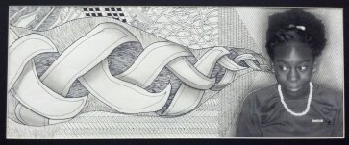
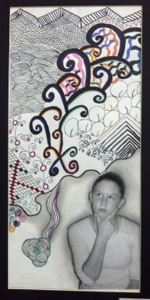
Steps:
- Mrs. Denison will take a photograph of you that gives the illusion of you thinking or dreaming.
- Place your photograph onto your paper so that you can create your Zentangle dream coming out of your head.
- Next, create a Zentangle stringer to break up the page.
- Now add Zentangle inspire patterns in each section you created.
- Add a minimum of FIVE values to your drawing. These should include highlights (white space), middle tones (gray areas) and black (extra dark areas).

