Student Name:

Lesson: Zentangle Letter
Circle the number in pencil that best shows how well you feel that you completed that criterion for the assignment. |  | Excellent | Good | Average | Needs Improvement
Criteria 1 – Breaking up the Shape: Student broke up the shape into numerous interesting sections to fill with the patterns. |  | 10 | 9 – 8 | 7 | 6 or less
Criteria 2 – Zentangle Patterns: Student utilized a variety of patterns in each letter. Patterns are well ordered and thought out with neatness in design. |  | 10 | 9 – 8 | 7 | 6 or less
Criteria 3 – Black vs. White. Student utilized the black sharpie to fill in about ½ of the patterns to create various values within the letter. |  | 10 | 9 – 8 | 7 | 6 or less
Criteria 4– Effort: took time to develop idea & complete project? (Didn’t rush.) Read the article and followed the steps within. Good use of class time? |  | 10 | 9 – 8 | 7 | 6 or less
Criteria 5 – Craftsmanship – Neat, clean & complete? Skillful use of the art tools & media? |  | 10 | 9 – 8 | 7 | 6 or less
Total: 50  (possible points) /50 pts | Grade:
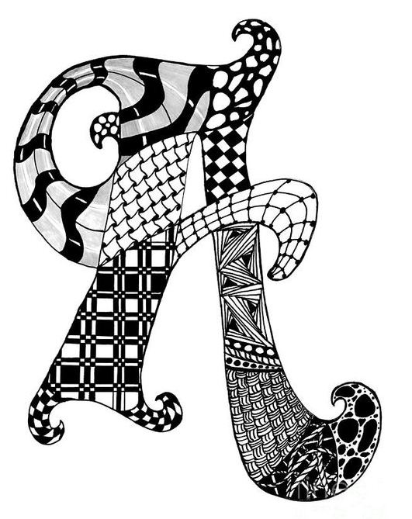
---Letter Design for Collaborative Art-------------------------------------
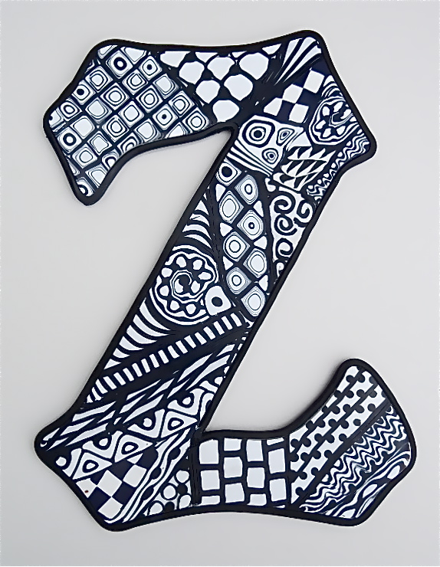
STEPS TO FOLLOW:

- Look through the handouts of sample zentangle letter images.
- Select a few designs that you would like to recreate in your letter. If you need to practice these in your sketchbook, please do so.
- Fill the letter with numerous zentangle designs in pencil. Use rulers and circle compasses if needed for good craftsmanship.
- Next, show Mrs. Denison to get the thin sharpie and trace over your designs. Pick about ½ of your designs to fill in black with the sharpies.
- You will then use the rubric below to grade yourself.

