Student Name:

Lesson: Zentangle Repeated Shapes and Pattern
Circle the number in pencil that best shows how well you feel that you completed that criterion for the assignment. |  | Excellent | Good | Average | Needs Improvement
Criteria 1 – Stencil use and Composition: Successful overall composition, overlapping the stencil to create interesting negative and positive space. Neatly traced the stencil to create uniform shapes. |  | 10 | 9 – 8 | 7 | 6 or less
Criteria 2 – Zentangle Patterns: Student utilized a variety of patterns in each stencil shape. Patterns are well ordered and have values with sharpie. |  | 10 | 9 – 8 | 7 | 6 or less
Criteria 3 – Watercolor. Student utilized one color of watercolor for the background (negative space) and a variety of watercolor in the foreground (positive shapes.) |  | 10 | 9 – 8 | 7 | 6 or less
Criteria 4– Effort: took time to develop idea & complete project? (Didn’t rush.) Read the article and followed the steps within. Good use of class time? |  | 10 | 9 – 8 | 7 | 6 or less
Criteria 5 – Craftsmanship – Neat, clean & complete? Skillful use of the art tools & media? |  | 10 | 9 – 8 | 7 | 6 or less
Total: 50  (possible points) /50 pts | Grade:
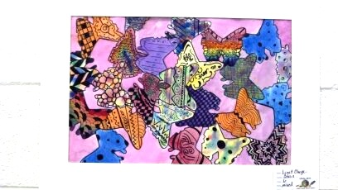
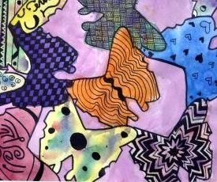
STEPS TO FOLLOW:
- Look through the handouts of sample stencil images.
- Create at least three thumbnail sketches of potential images to create a stencil.
- Next, Mrs. Denison will help to pick the best one to draw on poster paper to cut out and make your stencil.
- Once the stencil is cut out, you will use it to create a design on your 9x12 paper. Be sure to OVERLAP your images.
- Next, you will create Zentangle inspired patterns in each of the stenciled shapes and add sharpie for detail.
- Then, you will add watercolor to the background and in each of your Zentangle shapes.
- You will then use the rubric below to grade yourself.

------- Repeated Shapes & Pattern -------------------------------------

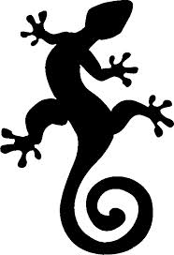
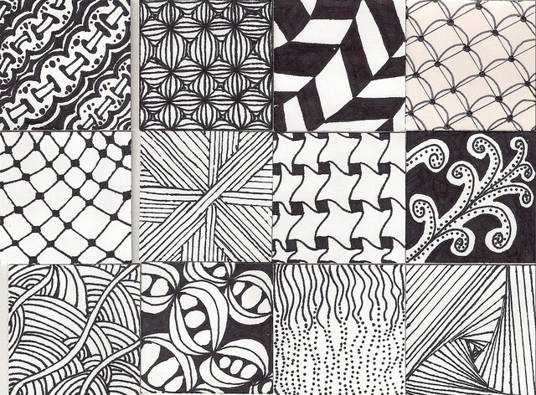
Below: Create 3 practice Zentangle drawings.
Above: Create 3 practice stencil drawings.

